Visualization

Cycle 1

Cady Pridgeon

Amee Kivette

Keanna Tennyson

Laura Wilson

### COMP 4710 Senior Design Project #3 Team Orange

Department of Computer Science and Software Engineering

Samuel Ginn College of Engineering, Auburn University

February 21, 2024

Table of Contents

**1. Introduction • Cady Pridgeon 4**

1.1. Project Mission 4

1.2. System Metaphor 4

**2. Previous Development • Amee Kivette 4**

**3. Cycle Intent • Laura Wilson 5**

**4. Future Work • Keanna Tennyson 5**

**5. User Stories • Cady Pridgeon 6**

**6. Design Documentation • Cady Pridgeon 13**

6.1. Architecture 13

6.2. Structure 14

6.3. Interfaces 18

6.4. Justifications of Decisions 21

6.5. Assumptions & Dependencies 21

**7. Management Plan • Cady Pridgeon 22**

7.1. Team Organization 22

7.2. Task Assignments 23

7.3. Development Schedule 24

**8. Risk Mitigation • Cady Pridgeon 24**

**9. Test Documentation • Cady Pridgeon, Amee Kivette 25**

9.1. Testing Plan 25

9.2. Acceptance Tests 25

9.3. Unit Tests 30

9.4. Test Logs 33

**10. Review Logs • Keanna Tennyson, Laura Wilson 36**

**11. Lessons & Challenges • Cady Pridgeon 37**

11.1. Lessons 37

11.2. Challenges 37

**12. Sponsor Approval • Cady Pridgeon 38**

**References • Cady Pridgeon 39**

**A. Appendix • Keanna Tennyson, Cady Pridgeon 40**

A.1. Meeting Minutes 40

A.2. Correspondence 44

A.3. Project Resources 47

A.4. Source Code 48

A.5. Version Description 48

A.6. Current Cycle Documents 49

A.7. Previous Cycle Documents 49

# 

# Introduction • Cady Pridgeon

The Alabama Authors of the 19th and 20th Centuries is a digital humanities project created by Dr. Beverley Park Rilett. This online resource provides access to information about Alabama authors and their published literature [1].

## Project Mission

The goal of the team is to enhance the Alabama Authors website with additional data visualizations. Currently, the only visualization on the project is a literary map. Dr. Rilett requested the addition of a chronology, similar to that of the one on her George Eliot Archive website. Thus, the mission of the Visualization Orange Team is to add a chronology that visualizes over 1,700 authors [1].

## System Metaphor

Data visualization is a remarkable feature of this project, currently in the form of a literary map and chronology. These visualization components are like a museum exhibit, allowing users to visually explore information before diving deeper into the details. While the map and chronology are the latest visualizations available, there is potential to research additional exhibits to enhance the learnability of the rich information the project holds [1].

# Previous Development • Amee Kivette

Development in the Architectural Spike primarily focused on exploring Omeka Classic to become familiar with its capabilities and limitations. Omeka Classic offers several temporal plugins that have different features and functionality to consider. Another crucial aspect of previous development was focused on data preparation. The team reviewed the Alabama Authors data with the project sponsor, Dr. Rilett, to build the initial collection. It was necessary to learn the basic application features of Omeka Classic to create a collection with the desired metadata.

# Cycle Intent • Laura Wilson

The primary goal of this cycle is to create an initial chronology prototype with all of the Alabama Authors data entries. At the end of the cycle, the team aims to deliver a chronology visualization that is robust, interactive, compliant with sponsor requirements, and compatible with Omeka Classic.

To achieve this goal, the team must add all Alabama Author data into Omeka Classic. Then, the team must identify which data visualization approach to use going forward by creating minimally viable product (MVP) prototypes with each tool. The team identified three plugins, Neatline, Neatline Time, and Timeline, that could produce a chronology within Omeka Classic. By creating low-fidelity prototypes with these plugins, the team can gain an understanding of the limitations posed by each plugin. Additionally, to satisfy sponsor needs, the team will experiment with D3.js to create a fully customizable visualization.

The team will present each MVP to the sponsor to obtain a decision about which approach to move forward with, considering each approach brings varying capabilities and constraints.

# Future Work • Keanna Tennyson

Going forward, the team plans to research additional visualizations and improvements to incorporate into the website. After researching Omeka Classic plugins for the chronology visualization, the group identified a few tools for graph-based visualizations. These plugins could facilitate further visualizations for the project [1]. Additionally, D3.js provides some interesting visualizations the team could leverage for the project.

The sponsor also mentioned some data refinements, such as collecting the complete birth and death date instead of solely the years. The team recorded these supplementary objectives in new user stories.

Accessibility and intuitive user experience are two priorities of the team. Since the primary target audience is professors and humanities academics, the user interface must be straightforward yet comprehensive. Subject matter experts will be very interested in the website content but will also desire uncomplicated navigation. Thus, the team aims to conduct usability testing to ensure a wholly accessible interface that is Web Content Accessibility Guidelines (WCAG) 2.2 AA compliant [1].

# User Stories • Cady Pridgeon

**Table 1. User Story 1.0 Chronology Data Visualization**

| **1.0 Chronology Data Visualization** | |
| --- | --- |
| Summary | As a user, I want to view authors on the Alabama Authors website in a chronology/timeline format to better explore and learn about the authors. |
| Description | Currently, the only visualization on the Alabama Authors website is a literary map. While this heatmap data visualization provides additional specific geographical context to the authors, a temporal visualization would also be interesting. This type of visualization enables users to explore the periods authors were alive and popular during to facilitate education, understanding, and research of the authors. |
| Planned Hours | Cycle: 40  Total: 40 |
| Actual Hours | Cycle: 25  Total: 25 |
| Coder | Cady Pridgeon, Amee Kivette |
| Tester | Cady Pridgeon |
| Reviewer | Cady Pridgeon, Amee Kivette, Keanna Tennyson, Laura Wilson |
| Status | In Progress |

**Table 2. User Story 1.1 Chronology Data Visualization**

| **1.1 Chronology Data Visualization** | |
| --- | --- |
| Summary | As a user, I want to be able to see author names, birth years, death years, and pictures when I hover over or select nodes to quickly learn about the author without having to navigate to their details page. |
| Description | Allowing users to see important information at a glance on the visualization supports their exploration and search of users. It also helps to differentiate nodes within the visualization. |
| Planned Hours | Cycle: 0  Total: 10 |
| Actual Hours | Cycle: 3  Total: 3 |
| Coder | Cady Pridgeon, Amee Kivette |
| Tester | Cady Pridgeon |
| Reviewer | Cady Pridgeon, Amee Kivette, Keanna Tennyson, Laura Wilson |
| Status | In Progress |

**Table 3. User Story 1.2 Chronology Data Visualization**

| **1.2 Chronology Data Visualization** | |
| --- | --- |
| Summary | As a user, I want to be able to interact with author nodes on the visualization to access their details page, allowing me to quickly learn more about authors directly from the chronology. |
| Description | There are detailed pages for each author in the database, so it would support research and education about authors by permitting users to access these informative pages straight from a visualization. The current literary map supports this functionality. |
| Planned Hours | Cycle: 0  Total: 10 |
| Actual Hours | Cycle: 3  Total: 3 |
| Coder | Cady Pridgeon, Amee Kivette |
| Tester | Cady Pridgeon |
| Reviewer | Cady Pridgeon, Amee Kivette, Keanna Tennyson, Laura Wilson |
| Status | In Progress |

**Table 4. User Story 1.3 Chronology Data Visualization**

| **1.3 Chronology Data Visualization** | |
| --- | --- |
| Summary | As a user, I want to be able to filter the visualization based on criteria, such as birth years and names, to customize my exploration of relevant information. |
| Description | Including filtering functionality better equips users for efficient data exploration. Without it, users may feel frustrated or experience cognitive overload if they are unable to access information of interest quickly and effectively. |
| Planned Hours | Cycle: 0  Total: 15 |
| Actual Hours | Cycle: 3  Total: 3 |
| Coder | Cady Pridgeon |
| Tester | Cady Pridgeon |
| Reviewer | Cady Pridgeon, Amee Kivette, Keanna Tennyson, Laura Wilson |
| Status | In Progress |

**Table 5. User Story 1.4 Chronology Data Visualization**

| **1.4 Chronology Data Visualization** | |
| --- | --- |
| Summary | As a user, I want to be able to export my visualization to keep for my records to conduct research or simply save my findings. |
| Description | Being able to quickly export a complex visualization into an image or PDF supports users in research and grants them a way to save progress after utilizing visualizations on the website. |
| Planned Hours | Cycle: 0  Total: 10 |
| Actual Hours | Cycle: -  Total: - |
| Coder | - |
| Tester | - |
| Reviewer | - |
| Status | Not Started |

**Table 6. User Story 1.5 Chronology Data Visualization**

| **1.5 Chronology Data Visualization** | |
| --- | --- |
| Summary | As a user, I want to view all of the Alabama authors from the 19th and 20th centuries to gain a complete picture of the literary landscape from this area and time. |
| Description | Currently, the website includes 150 authors in its literary map visualization and detail pages. However, there are around 1,500 data entries for authors from this time, so it is important to include these additional data points for completeness. |
| Planned Hours | Cycle: 3  Total: 5 |
| Actual Hours | Cycle: 3  Total: 5 |
| Coder | Cady Pridgeon |
| Tester | Cady Pridgeon, Amee Kivette |
| Reviewer | Cady Pridgeon, Amee Kivette, Keanna Tennyson, Laura Wilson |
| Status | Completed |

**Table 7. User Story 1.6 Chronology Data Visualization**

| **1.6 Chronology Data Visualization** | |
| --- | --- |
| Summary | As a user, I want to be able to access the Alabama Authors website from any device, such as a computer, tablet, or phone, and experience an accessible data visualization. |
| Description | The data visualization should be responsive, supporting users from any device, including a mobile phone. |
| Planned Hours | Cycle: 0  Total: 10 |
| Actual Hours | Cycle: -  Total: - |
| Coder | - |
| Tester | - |
| Reviewer | - |
| Status | Not Started |

**Table 8. User Story 1.7 Chronology Data Visualization**

| **1.7 Chronology Data Visualization** | |
| --- | --- |
| Summary | As a user, I want to experience an accessible user interface on the Alabama Authors website to ensure my abilities do not interfere with viable interactions on the website. |
| Description | Color contrast, tab index, and verbiage are a few aspects that make an interface accessible and inclusive. It is crucial that anyone, regardless of their abilities, should be able to access and navigate the website and visualizations with ease. |
| Planned Hours | Cycle: 0  Total: 10 |
| Actual Hours | Cycle: -  Total: - |
| Coder | - |
| Tester | - |
| Reviewer | - |
| Status | Not Started |

**Table 9. User Story 1.8 Chronology Data Visualization**

| **1.8 Chronology Data Visualization** | |
| --- | --- |
| Summary | As an administrator, I want to be able to manage the chronology/timeline data visualization with Omeka Classic to avoid issues with GitHub repository connections. |
| Description | Sometimes data visualizations are connected to the digital humanities websites by hosting the visualization on a GitHub repository and displaying the result on the website with an iframe. However, this is a frustrating solution for site administrators, since they often run into permissions and security restrictions. To prevent this, we must create our visualization using plugins supported by Omeka Classic. |
| Planned Hours | Cycle: 7  Total: 10 |
| Actual Hours | Cycle: 11  Total: 14 |
| Coder | Cady Pridgeon, Amee Kivette |
| Tester | Amee Kivette |
| Reviewer | Cady Pridgeon, Amee Kivette, Keanna Tennyson, Laura Wilson |
| Status | In Progress |

**Table 10. User Story 2.0 Author Details Page**

| **2.0 Author Details Page** | |
| --- | --- |
| Summary | As a user, I want to view an author's date of birth and date of death on their details page to quickly remember the period they lived through. |
| Description | While users can view an author's date of birth on data visualizations, their birth date and death date are missing from their detail page. This could frustrate users by creating an inconsistency in data availability over various pages on the site. |
| Planned Hours | Cycle: 0  Total: 10 |
| Actual Hours | Cycle: -  Total: - |
| Coder | - |
| Tester | - |
| Reviewer | - |
| Status | Not Started |

**Table 11. User Story 3.0 Sunburst Data Visualization**

| **3.0 Sunburst Data Visualization** | |
| --- | --- |
| Summary | As a user, I want to view authors on the Alabama Authors website in a zoomable sunburst format to better interact with and explore the authors. |
| Description | A sunburst-style visualization would enable users to drill down specific periods to identify and analyze authors by period. This would facilitate the education, understanding, and research of the authors. |
| Planned Hours | Cycle: 0  Total: 20 |
| Actual Hours | Cycle: 1  Total: 1 |
| Coder | Amee Kivette |
| Tester | - |
| Reviewer | - |
| Status | In Progress |

**Table 12. User Story 4.0 Birth Date Data**

| **4.0 Birth Date Data** | |
| --- | --- |
| Summary | As a user, I want to view an author's birth and death dates instead of birth and death years on visualizations to get a complete picture of the author's information. |
| Description | Only the author's birth and death years are collected and stored in the data. However, birth dates could potentially be scraped from descriptions to generate a more complete profile for each author. |
| Planned Hours | Cycle: 0  Total: 20 |
| Actual Hours | Cycle: -  Total: - |
| Coder | - |
| Tester | - |
| Reviewer | - |
| Status | Not Started |

# Design Documentation • Cady Pridgeon

## Architecture

This project uses Omeka Classic and Reclaim Hosting for management and hosting. Omeka Classic is a content management system (CMS) for archives and educational collections. This is where site administrators can go to add, update, and remove data. Since the primary user group for this website is academics in the humanities, it is user-friendly and not overly technical. Reclaim Hosting facilitates web hosting for educational institutions. This is where the website design controls are located [1].

The primary interactions in this project are users with the data through Omeka Classic visualizations, the data with Omeka Classic, Omeka Classic with Reclaim Hosting, and administrators with the data. Within Omeka Classic, interactions between the data and plugins facilitate data visualization [1].

Currently, there is experimentation being done with D3.js visualizations and GitHub Pages. While it is not yet incorporated into the project, the data is being used to create an interactive chronology visualization using D3.js. This visualization is then hosted on GitHub Pages. Ideally, this visualization would be embedded in an Omeka Classic page, but this has not yet been finalized. Thus, this visualization remains an external tool for the time being.

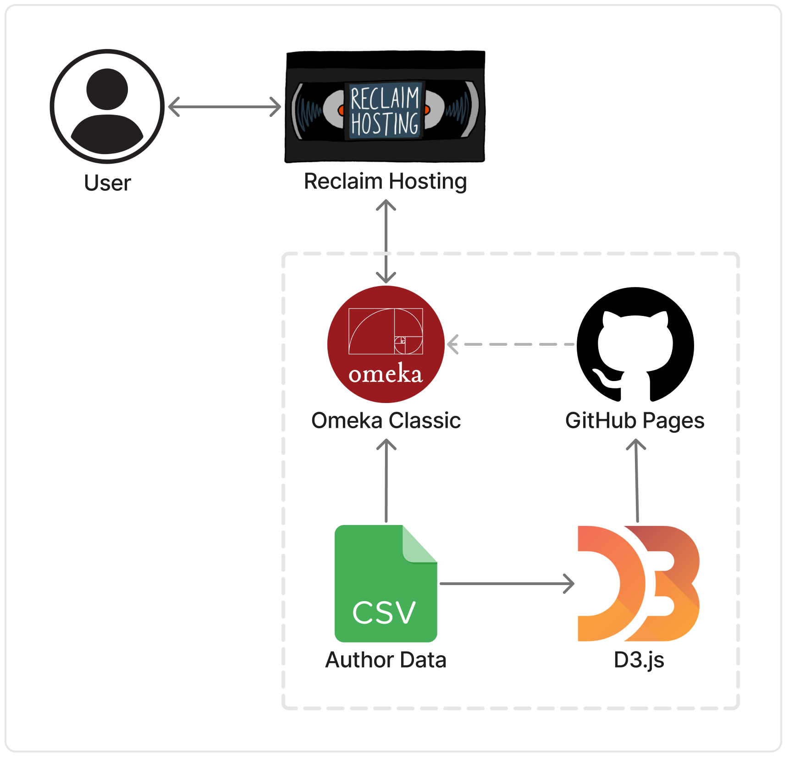

**Figure 1. Architecture Diagram: Technology Flow Chart**

## Structure

A team of researchers has been collecting and refining the Alabama Author dataset, bringing the number of author entries to over 1700. All of the data used within the project originates from this document. Currently, the data is stored in a spreadsheet on Auburn Box.

The original collection of data contains the following fields:

* Author_Last_Name_First_Name: “Last name, first name” (all caps)
* Author_Portrait_Link: Link to author image on Auburn Box
* Author_First_Name_Last_Name: “First name last name”
* Author_Pseudonym_Name: “Pseudonym”
* Author_Dates: Author lifespan, “Birth year-death year”
* City: Associated city
* County: Associated county
* Place_Of_Education: Associated education location
* Birth_Place: Associated place of birth
* Adult_Residence: Associated location of adult residence
* Place_Of_Death: Associated place of death
* Author_Biography: Short author description/biography
* Source: Referenced source(s)
* Book_Publications: Published books
* Book_Publications_Post_2000: Published works after 2000
* Other_Publications: Any other published works

The following fields were added to facilitate chronology data visualizations:

* Birth_Date: Birth year, extracted from Author_Dates
* Death_Date: Death year, extracted from Author_Dates
* Lifespan: Years lived, calculated from Birth_Date and Death_Date
* Author_First_Name_Last_Name_Author_Dates: Display name, created by concatenating Author_First_Name_Last_Name and Author_Dates
* New_Date: Author_Dates in a new format, including January 1 as placeholder month and day for each Birth_Date and Death_date, concatenated with a “/” between
* Page_Link: Link to author details page
* Image_Name: File name of author image

This spreadsheet can be converted into a comma-separated values (CSV) file for data processing. On Omeka Classic, data can be stored in collections, which utilize Dublin Core for categorization and organization across the site. Dublin Core defines metadata items within collections to assist in describing each field.

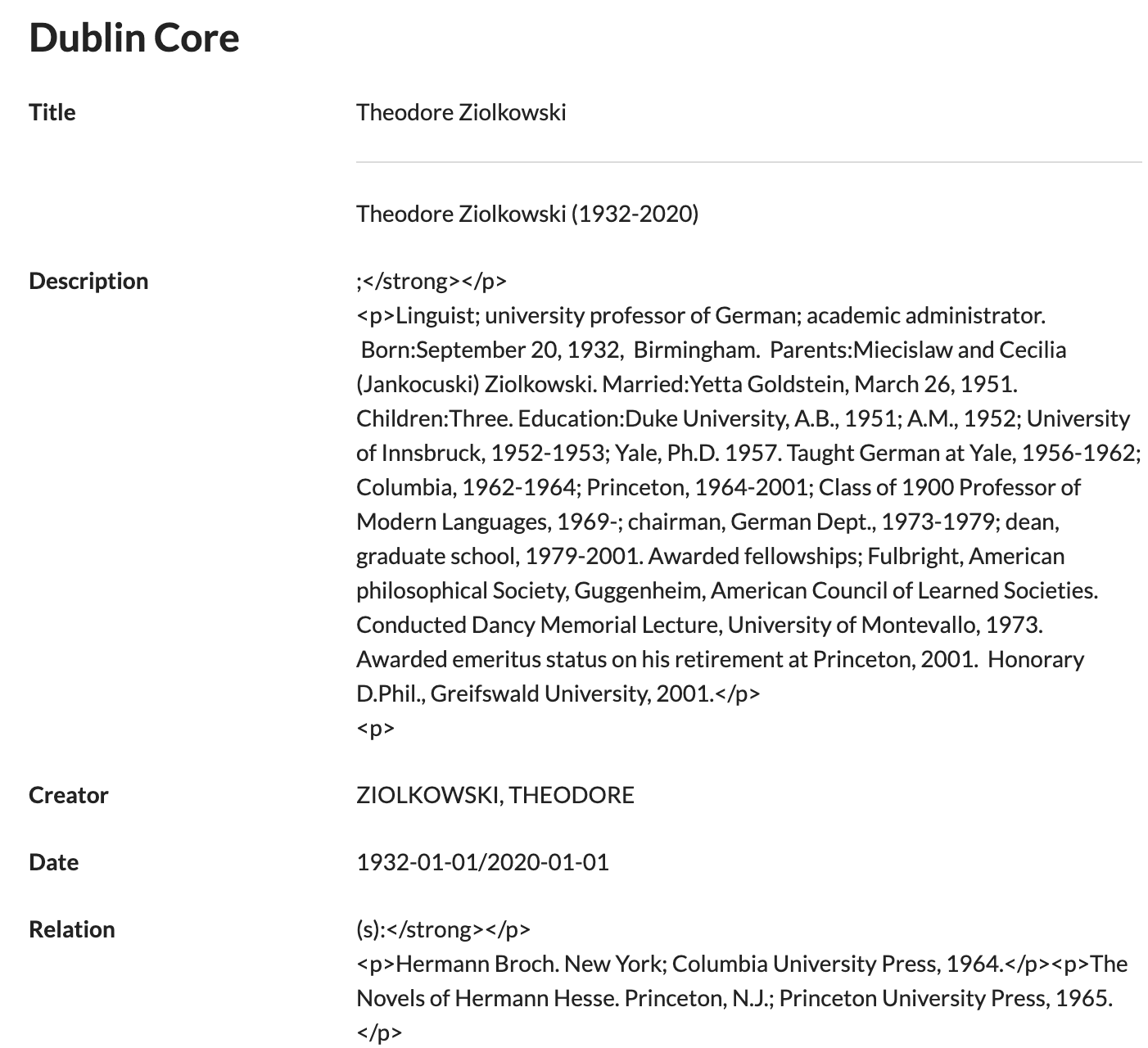

**Figure 2. Sample Author Dublin Core Metadata Fields**

Most of the data field to metadata category assignments are straightforward, but it can be beneficial to gain an understanding of the Dublin Core metadata definitions and intended usages. For this project, the identifier field is used to create relations between items, so the team was advised to refrain from utilizing this metadata attribute.

After attaching proper metadata tags to each data field, Omeka Classic stores the data in a collection. From a collection, author objects and respective attributes can be passed into internal pages and plugins. Collections can be displayed in a tabular format with sort features. Additionally, collections can be parsed within Omeka Classic plugins, which often provide data visualization capabilities. Since data visualization is the focus of the Alabama Authors project, the team heavily focused on the interactions between collection data and plugins, as opposed to those of simple pages and exhibits.

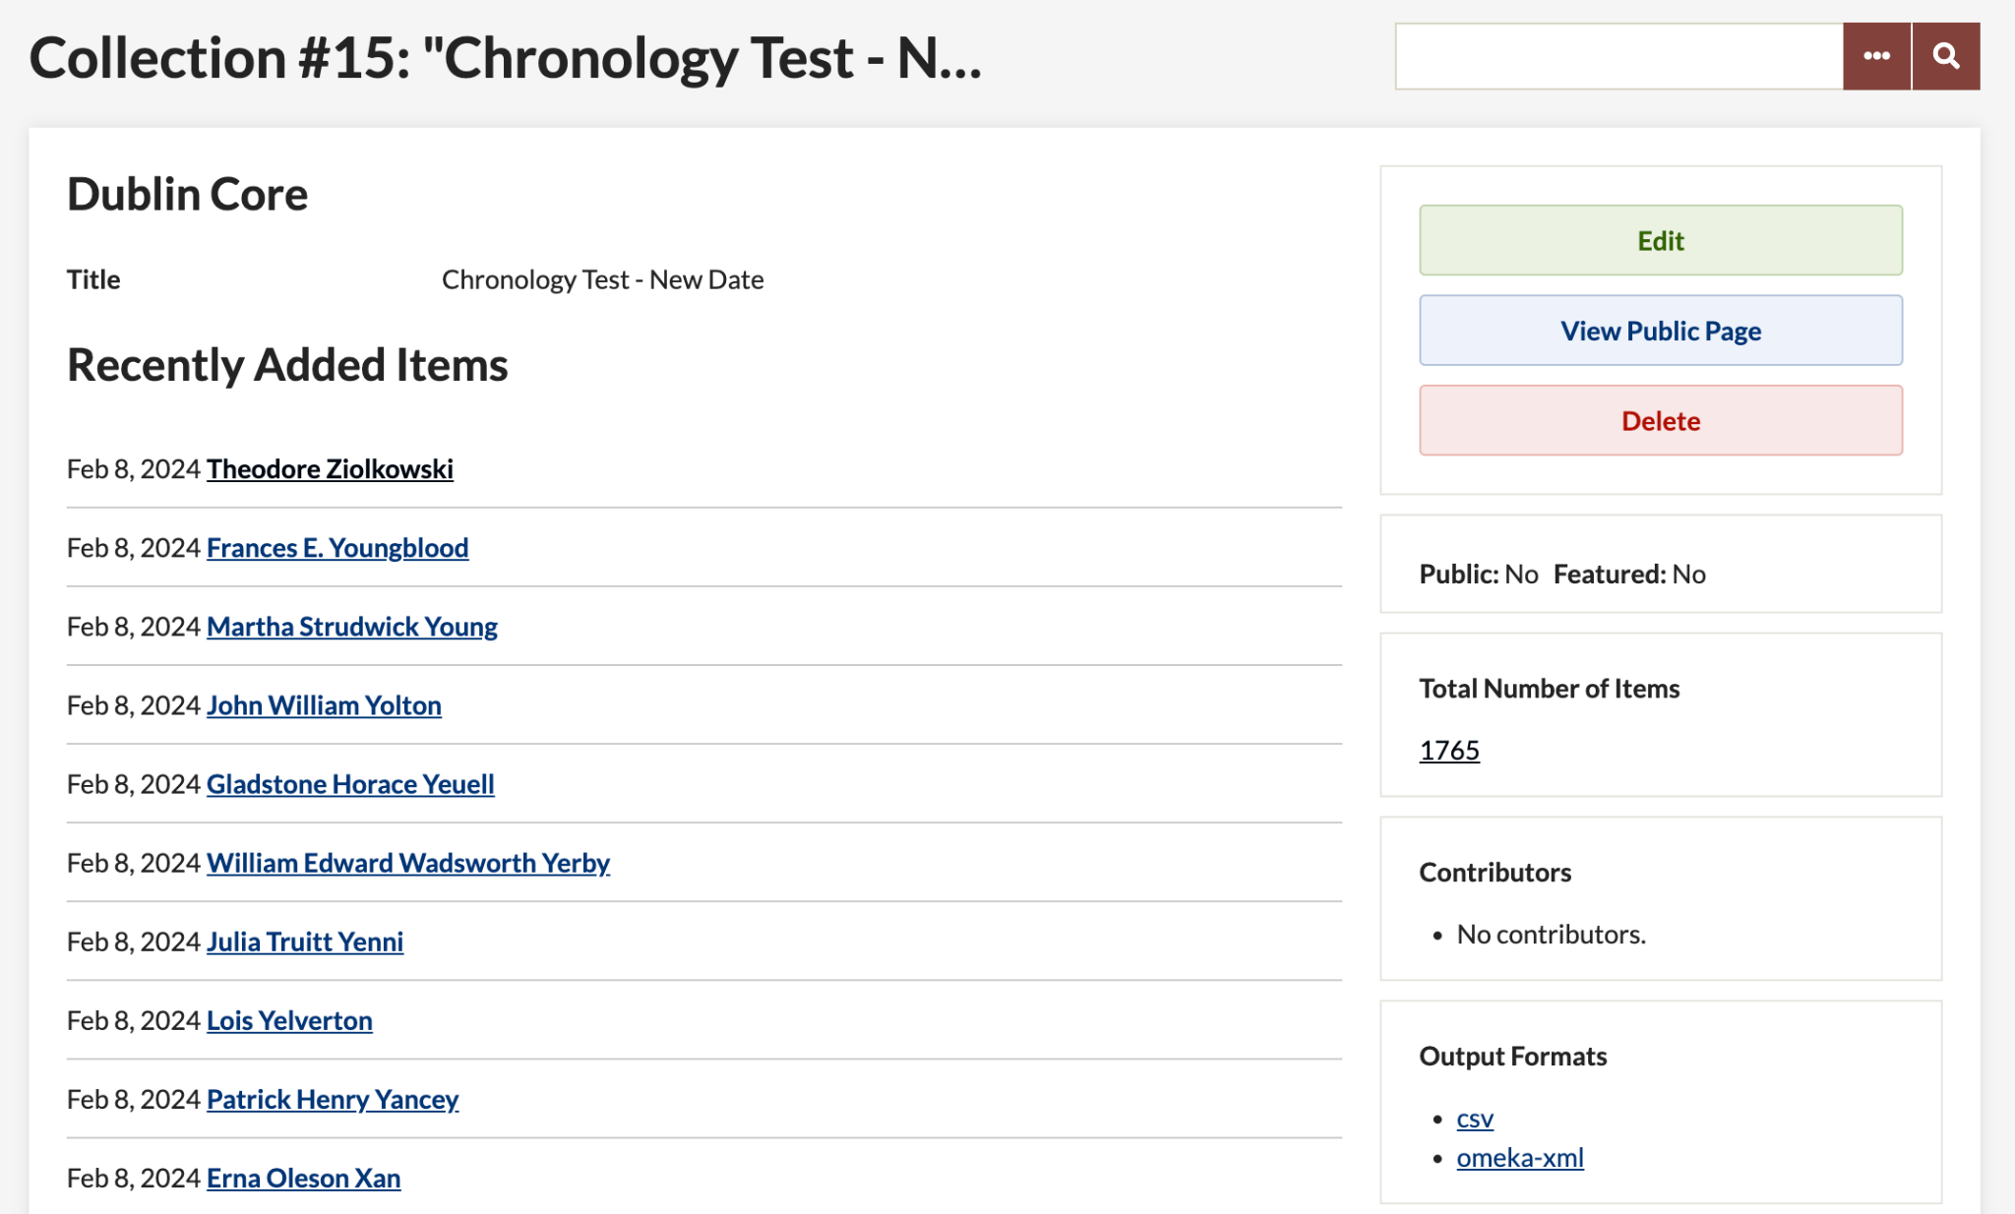

**Figure 3. Chronology Test Collection on Omeka Classic**

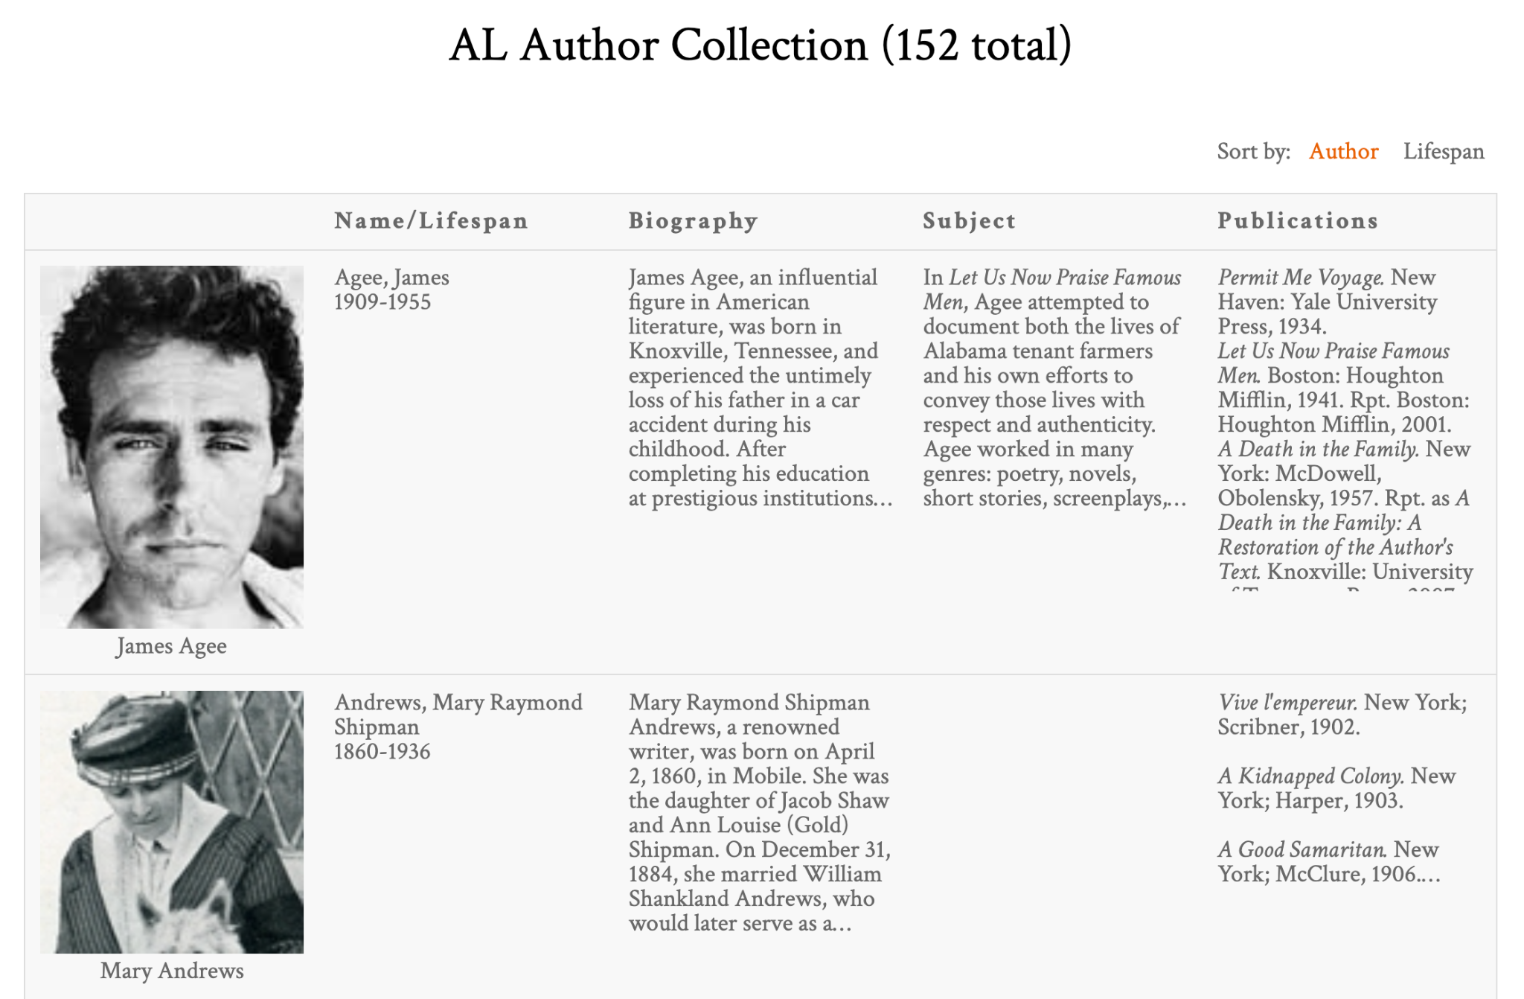

**Figure 4. Alabama Author Collection on Page with Tabular Format**

## Interfaces

Omeka Classic allows the use of supported plugins to facilitate data parsing and visualization on a website. During team research, the following plugins were identified as possible means by which a chronology could be created within Omeka Classic [1]:

* Neatline Time
* Timeline
* Neatline

The Neatline Time plugin provides a very basic interface, displaying thin bars for each author instance on the timeline. The time axis can be centered on a specified date, but it cannot be specified any further. Due to this constraint, navigation of the visualization may cause user frustration. The plugin maintains a granular view of the data, which minimizes the impact of the number of author data entries collected. It provides basic author information, such as author name, lifespan, description, and link. Thus, it does not provide any unique functionality that sets it apart from similar plugins.

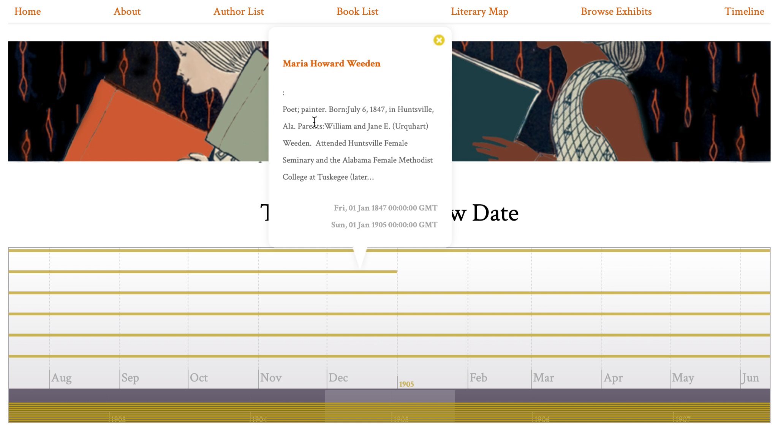

**Figure 5. Omeka Classic Neatline Time Plugin Chronology Visualization**

The Timeline plugin provides an interesting interface. The timeline portion of the visualization resembles the Neatline Time plugin, but it does provide more functionality. It has four navigation help options, including zoom in, zoom out, jump to front, and jump to back. Additionally, when a user clicks on an author span, instead of populating a tooltip, the author information shows in the space above the timeline. This allows for increased focus on the author, as well as more room for detailed information. The plugin also contains arrows at the top, allowing for navigation to the next or previous author, based on birth year. However, the primary drawback to this plugin is its latency. This plugin is the slowest of the three due to its navigation features.

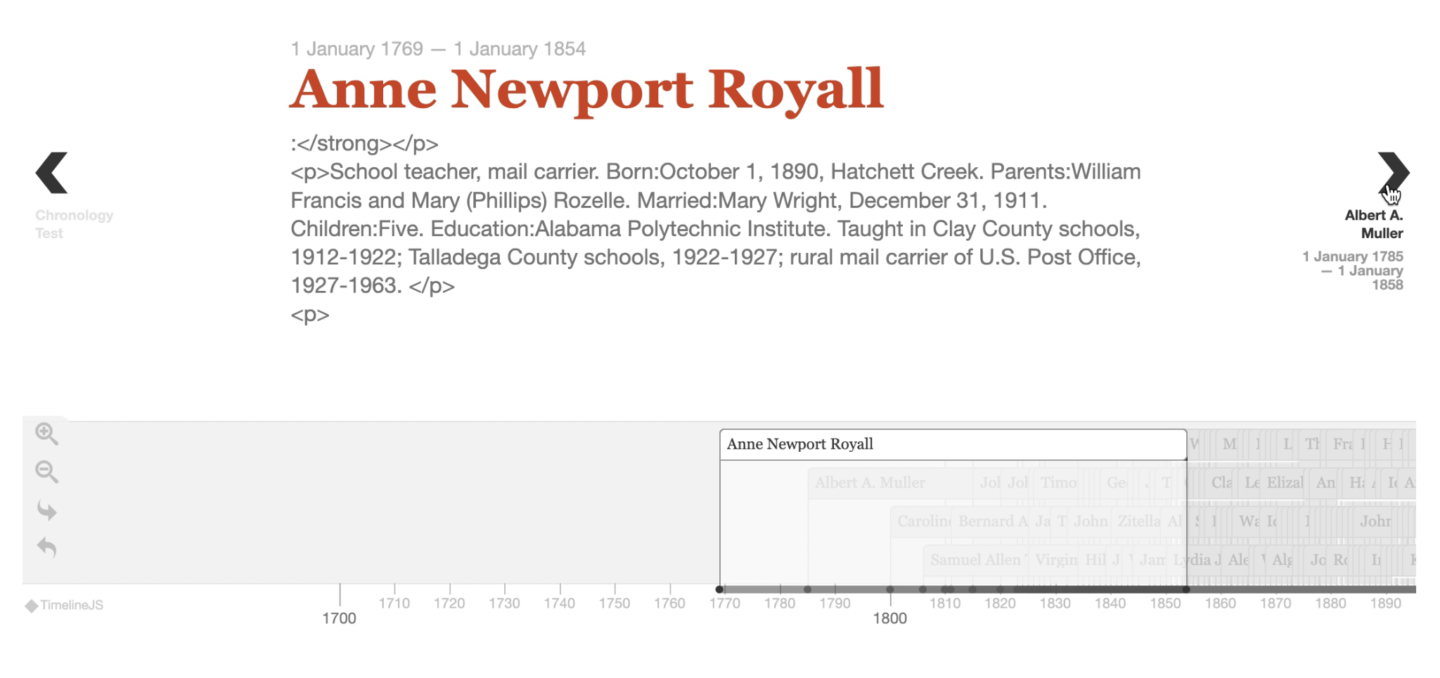

**Figure 6. Omeka Classic Timeline Plugin Chronology Visualization**

The Neatline plugin provides more functionality within its interface, allowing users to click on a predefined area of an image to zoom in and explore. It is currently used for the Literary Map on the Alabama Authors website because of this feature. When clicking on authors, the information listed is customizable, allowing for increased specification of the system. With its increased interactivity and personalization, it seems promising for the chronology. However, all information available on the visualization must be entered manually. This includes any author information, such as their image and link, and developers would have to manually activate the SIMILE Timeline widget for each entry.

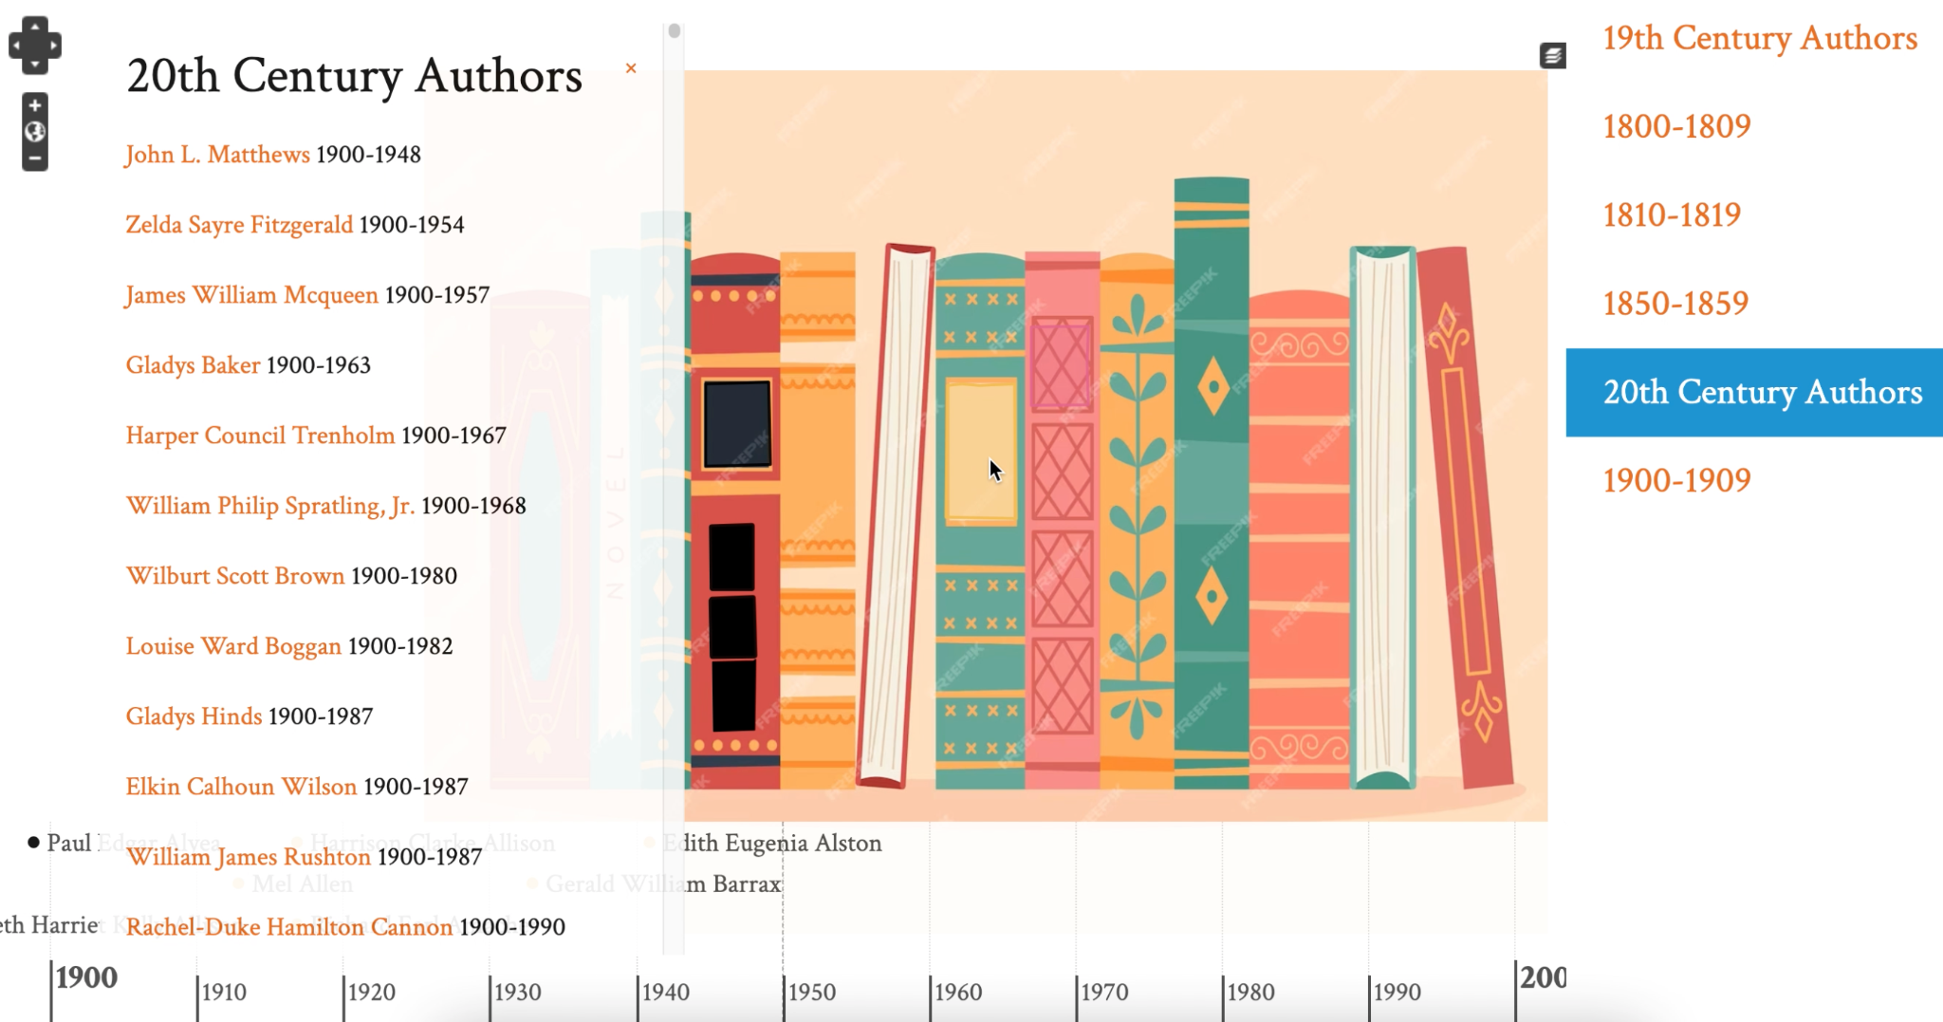

**Figure 7. Omeka Classic Neatline Plugin Chronology Visualization**

Two additional plugins, AvantRelationships and Archiviz, were identified for possible data visualization in a graphical format. If time permits, these could be interesting visualization options to increase data exploration capabilities [1].

One external data visualization tool was explored for experimentation purposes. The project sponsor expressed interest in seeing robust and interactive visualizations, even if they needed to be hosted externally and interfaced with Omeka Classic. The team decided to investigate D3.js, a JavaScript library for creating interactive data visualizations. Additionally, the sponsor suggested that HTML and JavaScript source code could potentially be embedded into Omeka Classic pages. Thus, there is an additional visualization that utilizes the D3.js library. The visualization is in a zoomable bar chart style, with author information on a hover state and sort functionality. Unfortunately, the visualization does not seem to properly interface with Omeka Classic, but it is a top priority to discuss this with sponsors at their earliest convenience.

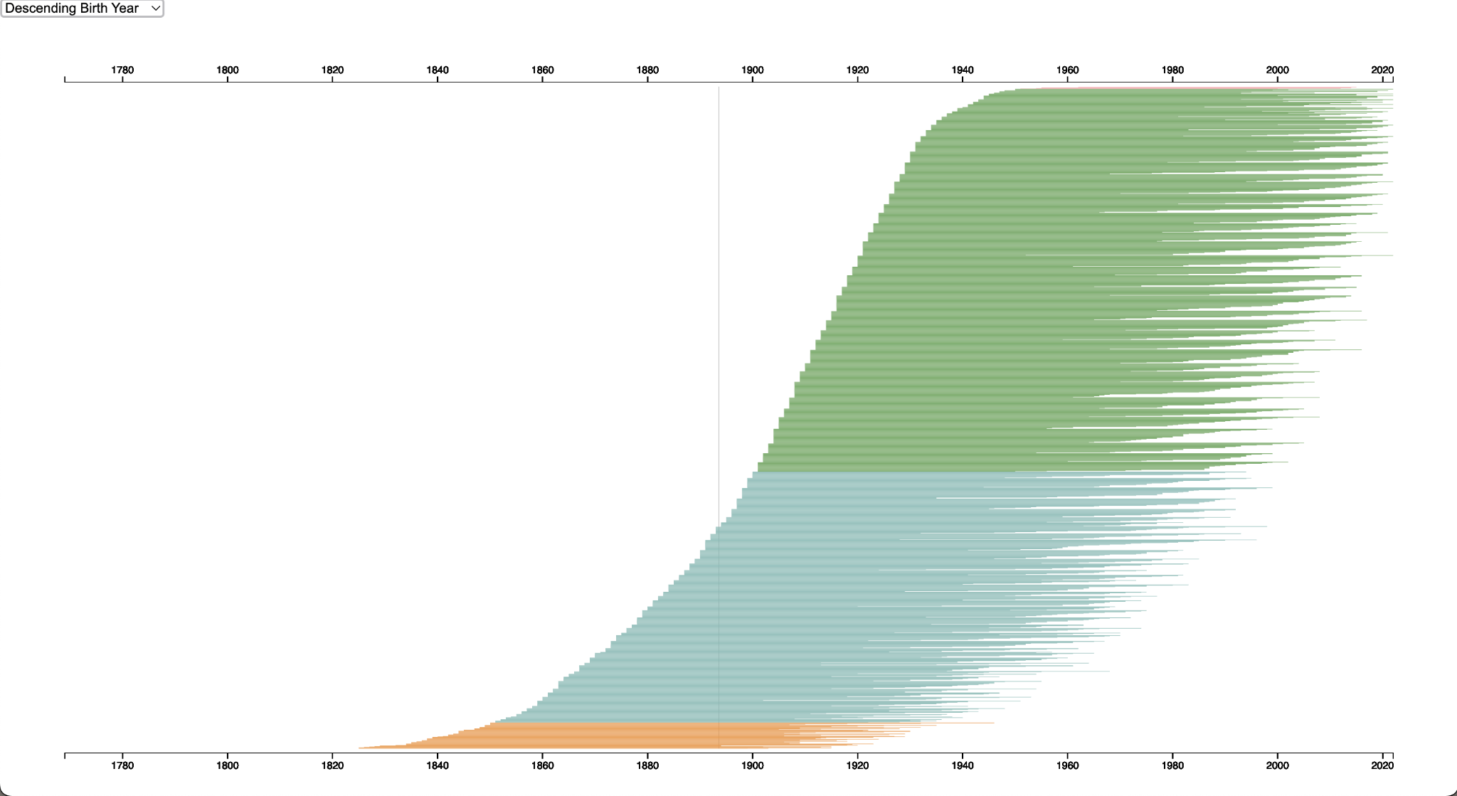

**Figure 8. D3.js Bar Chart Chronology Visualization**

## Justifications of Decisions

Most of the project design decisions were previously established. Omeka Classic and Reclaim Hosting have been used for prior projects, so the project sponsor required that the team utilize this architecture for Alabama Authors.

During the initial meeting, the sponsor advised against hosting visualizations on GitHub repositories and displaying them on the website using an iframe. This solution was suggested to be avoided since it causes permissions and security issues for administrators. Thus, the team decided to move forward with plugins supported internally within Omeka Classic.

However, at the most recent sponsor meeting, the sponsor requested more advanced functionality than the plugins offered and encouraged the team to pursue more experimental solutions. This is why the team created a visualization with D3.js. The team awaits sponsor feedback before pursuing a particular solution.

## Assumptions & Dependencies

This model assumes that the primary data source is the Alabama Authors CSV file. However, there are additional data sources, namely a collection of literary works by the authors. Currently, it is not in the project scope to foster interactions with this data, but if time permits, additional visualizations regarding this dataset may be investigated [1].

The capabilities of the chronology visualization heavily rely on the flexibility and comprehensiveness of the plugins available on Omeka Classic. Since the sponsors advise avoiding creating a visualization hosted on GitHub, the team is likely limited to the capabilities available on Omeka Classic [1]. If the sponsors determine that hosting on GitHub is acceptable, the team could move forward with the D3.js solution. However, keeping security and permission concerns in mind, selecting the less customizable but more secure option may be favorable.

# Management Plan • Cady Pridgeon

## Team Organization

For team communication, group messages, email, and Zoom are utilized. These mediums of communication allow for quick discussion of project matters. To coordinate with Dr. Rilett, the team uses email, Zoom, and in-person meetings to discuss weekly progress and tasks. To organize and schedule team meetings, Microsoft Excel is used. The cycle status reports also help the team with productivity and time management [1].

To manage user stories and tasks, a Kanban taskboard is leveraged. The team has a shared workspace on Notion where an Agile-style development process is carried out [1].

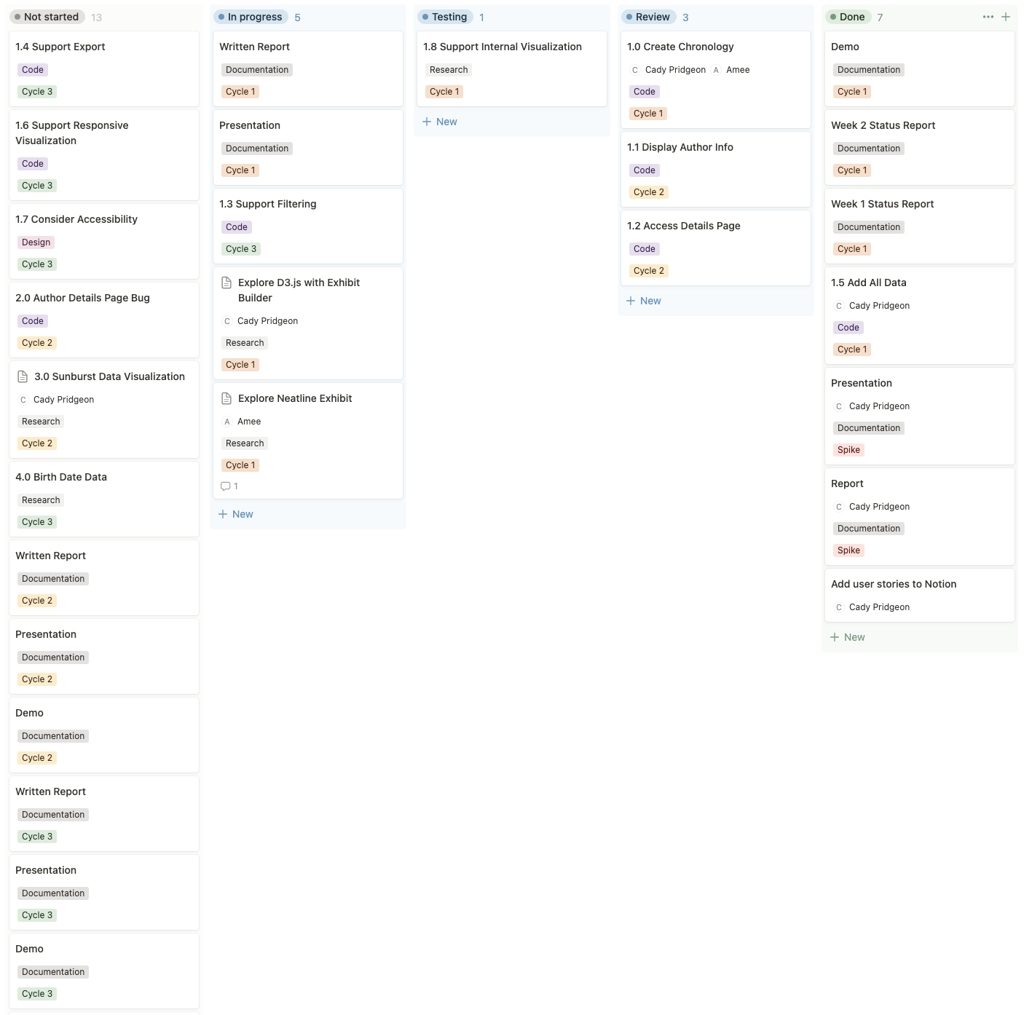

**Figure 9. Notion Kanban Board for Task Management**

For the code base, Omeka Classic is used for content management and data import. Reclaim Hosting houses the user interface design and controls [1]. GitHub is utilized to host the experimental D3.js visualization.

## Task Assignments

The team established some general roles for each member during the Architectural Spike. These roles are as follows:

* Cady Pridgeon: Deliverables Coordinator & Developer
* Amee Kivette: Developer
* Keanna Tennyson: Meeting Coordinator
* Laura Wilson: Reviewer

During Cycle 1, the team divided up tasks as follows:

* Cady Pridgeon: Finish cleaning and uploading author data to Omeka Classic, experiment with Neatline Time and Timeline plugins, create D3.js visualization
* Amee Kivette: Create Neatline visualization, create sample sunburst chart, review cleaned author data
* Keanna Tennyson: Organize team meetings, take meeting minutes, review visualizations
* Laura Wilson: Review visualizations, explore any outlying visualization options

## Development Schedule

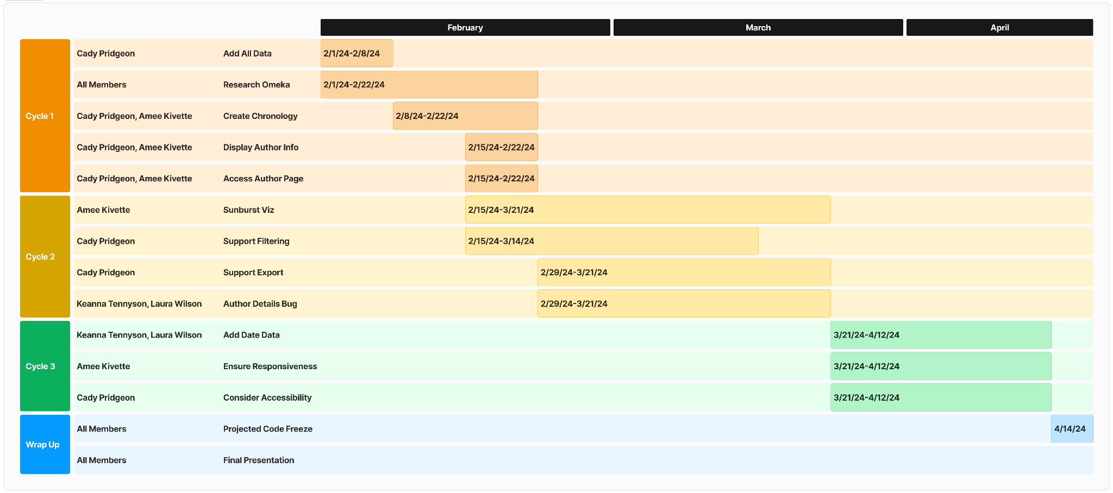

**Figure 10. Gantt Chart with Estimated Development Schedule and Projected Code Freeze**

# Risk Mitigation • Cady Pridgeon

During the Architectural Spike, the project sponsors identified risks associated with a common approach to data visualization in similar projects. In previous semesters, students hosted their visualizations on the website by creating their projects on GitHub and utilizing iframes to display their work. However, the project web developer advised that this approach leads to security and permissions issues down the road [1]. Thus, the team focused Cycle 1 on creating an MVP visualization with Omeka Classic plugins. This ensures that the group has visualizations to pursue within the current CMS.

On the other hand, many of the plugins offered within Omeka Classic are not very flexible or customizable. To ensure we have a backup visualization, the team decided to pursue the development of one experimental visualization using D3.js. Additionally, to better align with sponsor requests, this visualization provides a more impactful visualization. If the sponsor approves the use of GitHub for the hosting approach, the team will have this solution to fall back on.

Overall, the team plans to maintain an open line of communication with the project sponsor to request feedback and confirm concrete next steps based on the current solutions.

# Test Documentation • Cady Pridgeon, Amee Kivette

## Testing Plan

Since this project is visualization-based, the team decided to pursue a manual testing method. Team members will think of nominal cases and edge cases to test visualizations with. The team will then record test action steps, expected results, and actual results to determine the test result. After receiving the results, the team will pursue the next steps accordingly.

This visual approach to testing may not guarantee that the code is completely free of bugs, but it does confirm that the functionality of the visualization is up to standards. Especially within the Omeka Classic system, generating automatic, code-based tests is not practical for this project.

For further verification, the team aims to present each test to the sponsors to gain additional feedback and receive approval.

## Acceptance Tests

**Table 13. D3.js Chronology Basic Functionality Test**

| **D3.js Chronology - Basic Functionality** | | | | |
| --- | --- | --- | --- | --- |
| User Story | | 1.0, 1.1 Chronology Data Visualization | | |
| Test Description | | Testing for basic information and functionality on the D3.js chronology visualization. | | |
| Programs/Files | | GitHub, index.html, authors.csv | | |
| Step | Action | Expected Result | Actual Result | Status |
| 1 | Scroll down on trackpad. | Visualization zooms in. | Visualization zooms in based on cursor location. | Pass |
| 2 | Hover over a bar. | Author information shows on a tooltip. | Author name, lifespan, years lived, and county (if available) show on the tooltip. | Pass |
| 3 | Bar visualization correlates to the correct author and lifespan. | Bar length correctly lines up with birth year and death year. | The bar length does line up with the year axis. | Pass |

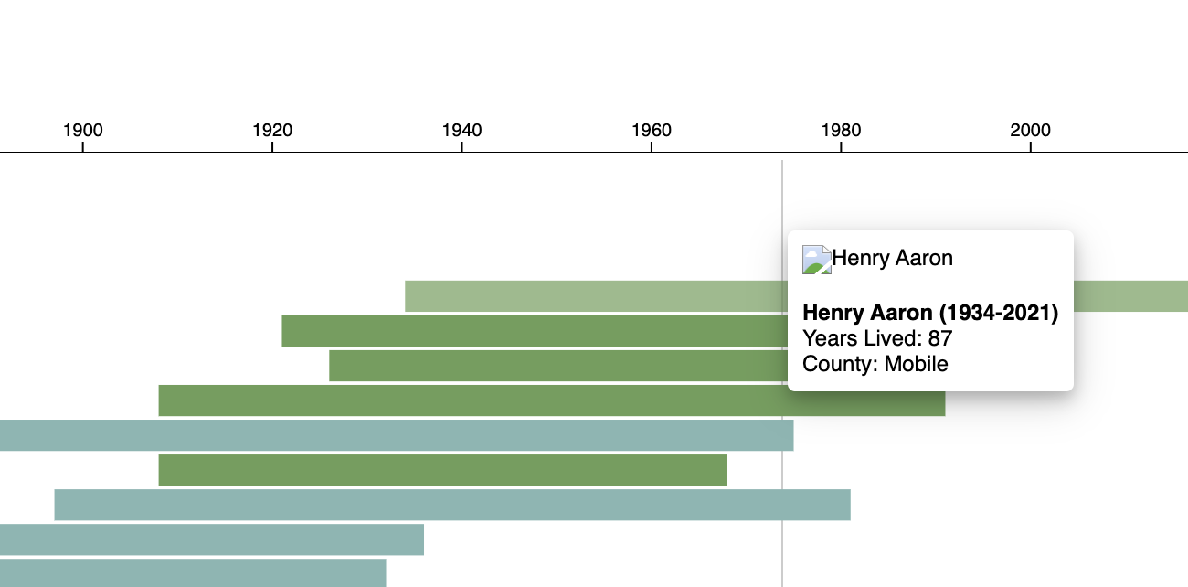 **Figure 11. D3.js Chronology Basic Functionality Test Results**

**Table 14. D3.js Chronology Complex Functionality Test**

| **D3.js Chronology - Complex Functionality** | | | | |
| --- | --- | --- | --- | --- |
| User Story | | 1.0, 1.1, 1.2 Chronology Data Visualization | | |
| Test Description | | Testing for advanced interaction states and added information on the D3.js chronology visualization. | | |
| Programs/Files | | GitHub, index.html, authors.csv, images | | |
| Step | Action | Expected Result | Actual Result | Status |
| 1 | Scroll down on trackpad. | Visualization zooms in. | Visualization zooms in based on cursor location. | Pass |
| 2 | Hover over a bar. | Author information shows on a tooltip, including author image. | Bar lightens and author information shows on the tooltip, including the author image when available. Additionally, there is a guiding vertical line to assist with axes alignment. | Pass |
| 3 | Click on a bar. | Alabama Authors details page opens. | When the page link is available, the correct page opens in a new tab. | Pass |

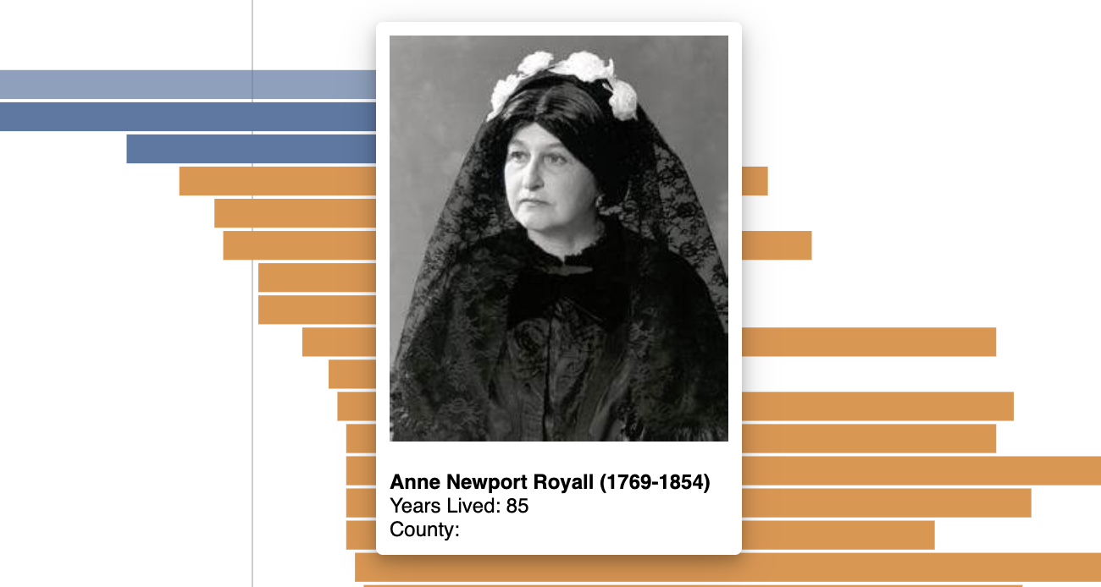

**Figure 12. D3.js Chronology Complex Functionality Test Results**

**Table 15. Neatline - Basic Functionality of SIMILE Timeline Widget**

| **Neatline - Basic Functionality of SIMILE Timeline Widget** | | | | |
| --- | --- | --- | --- | --- |
| User Story | | 1.0, 1.2 Chronology Data Visualization | | |
| Test Description | | Testing for basic information and functionality on the Neatline chronology visualization with SIMILE Timeline widget activated. | | |
| Programs/Files | | AuthorData.csv | | |
| Step | Action | Expected Result | Actual Result | Status |
| 1 | Scroll up and down using a mouse or side to side using the trackpad. | The timeline moves left or right. | The timeline moves left (toward earlier dates) when scrolling down. The timeline moves right( toward later dates) when scrolling up. | Pass |
| 2 | Click author's name on the timeline. | Author information is displayed in a popover. | Author information is displayed in a popover containing a link to the collection. | Pass |

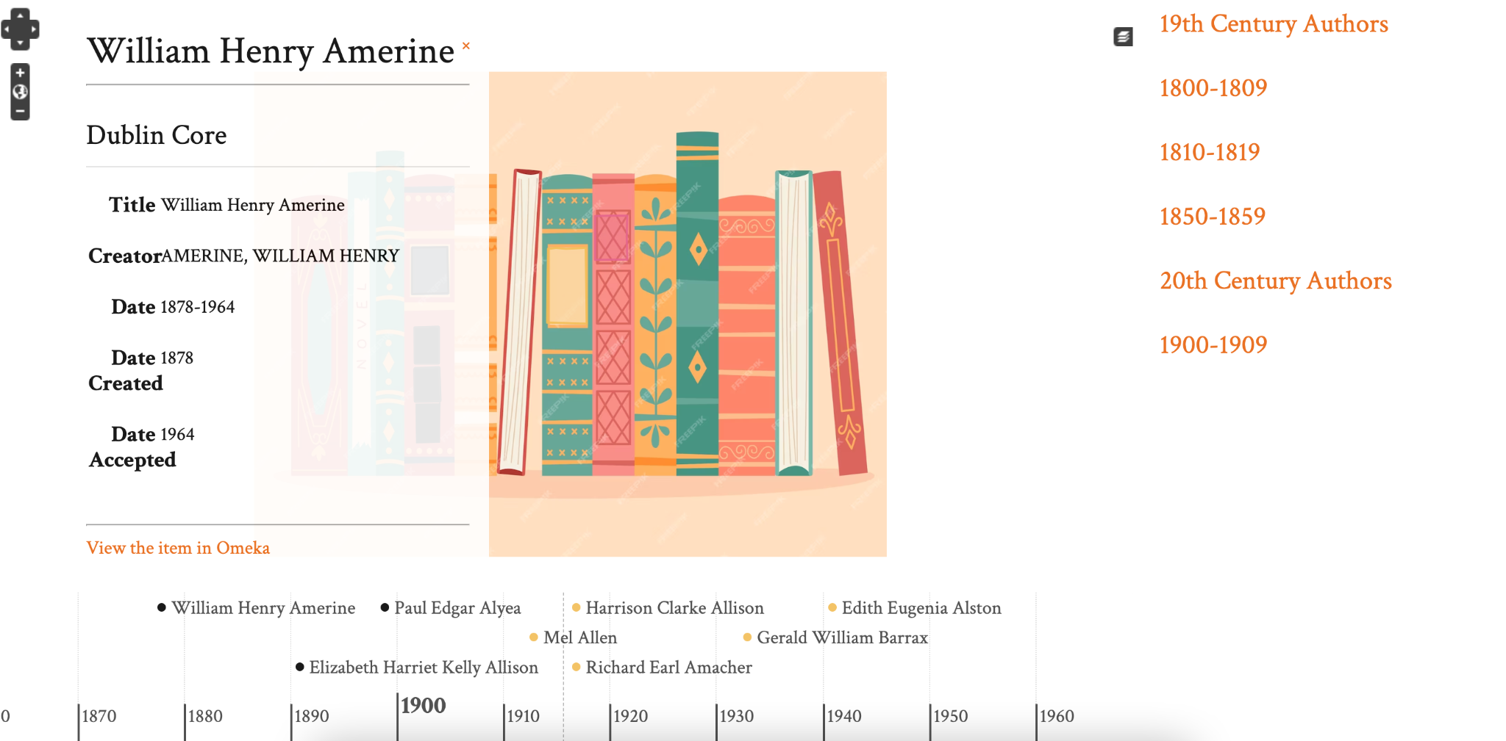

**Figure 13. Basic Functionality of SIMILE Timeline Widget Test Results**

**Table 16. Neatline - Basic Functionality of Waypoints Widget**

| **Neatline - Basic Functionality of Waypoints Widget** | | | | |
| --- | --- | --- | --- | --- |
| User Story | | 1.0, 1.1, 1.2 Chronology Data Visualization | | |
| Test Description | | Testing for basic information and functionality on the Neatline chronology visualization with SIMILE Timeline and Waypoints widgets activated. | | |
| Programs/Files | | AuthorData.csv | | |
| Step | Action | Expected Result | Actual Result | Status |
| 1 | Scroll up and down using the mouse. | The background image zooms in and out. | The background image zooms in and out. | Pass |
| 2 | Hover over defined areas on the background image. | Associated period displays in a popover. | Associated period displays in a popover and is highlighted in the navigation pane. | Pass |
| 3 | Click the defined area on the background image. | A list of authors appears in a popover. The timeline centers on the selected time. | A list of authors appears in a popover. The timeline centers on the selected time. | Pass |
| 4 | Click item in the navigation pane. | A list of authors appears in a popover. The timeline centers on the selected period. | A list of authors appears in a popover. The timeline centers on the selected period. The image zooms to the associated region. | Pass |

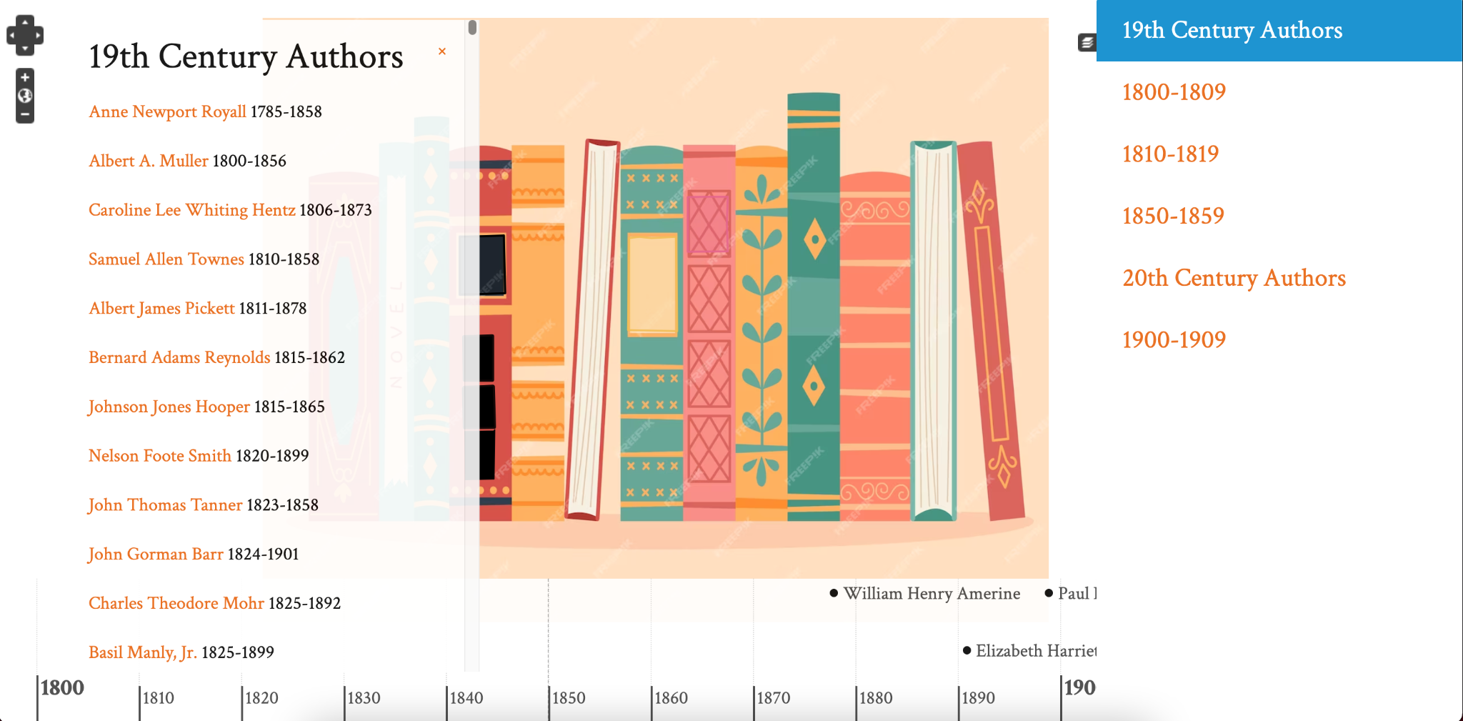

**Figure 14. Basic Functionality of SIMILE Timeline Widget Test Results**

## Unit Tests

**Table 17. D3.js Chronology Zoom Unit Test**

| **D3.js Chronology - Zoom** | | | | |
| --- | --- | --- | --- | --- |
| User Story | | 1.0 Chronology Data Visualization | | |
| Test Description | | Testing for zoom functionality on D3.js chronology visualization. | | |
| Programs/Files | | GitHub, index.html, authors.csv | | |
| Step | Action | Expected Result | Actual Result | Status |
| 1 | Scroll down on the trackpad. | Zoom into bars. | Zoom into bars that the cursor is nearest to. | Pass |
| 2 | Click and drag up. | Move up to view the bars above. | Moves up on visualization. | Pass |
| 3 | Click and drag down. | Move down to view the bars below. | Moves down on visualization. | Pass |
| 4 | Scroll up on the trackpad. | Zoom out to view all bars. | Zooms out using the cursor as the point of reference. | Pass |

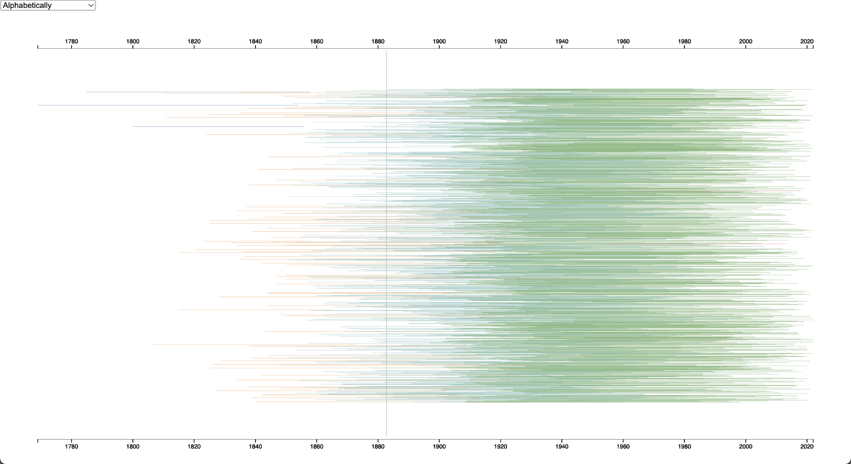

**Figure 15. D3.js Chronology Zoom Test Results - Zoom Out**

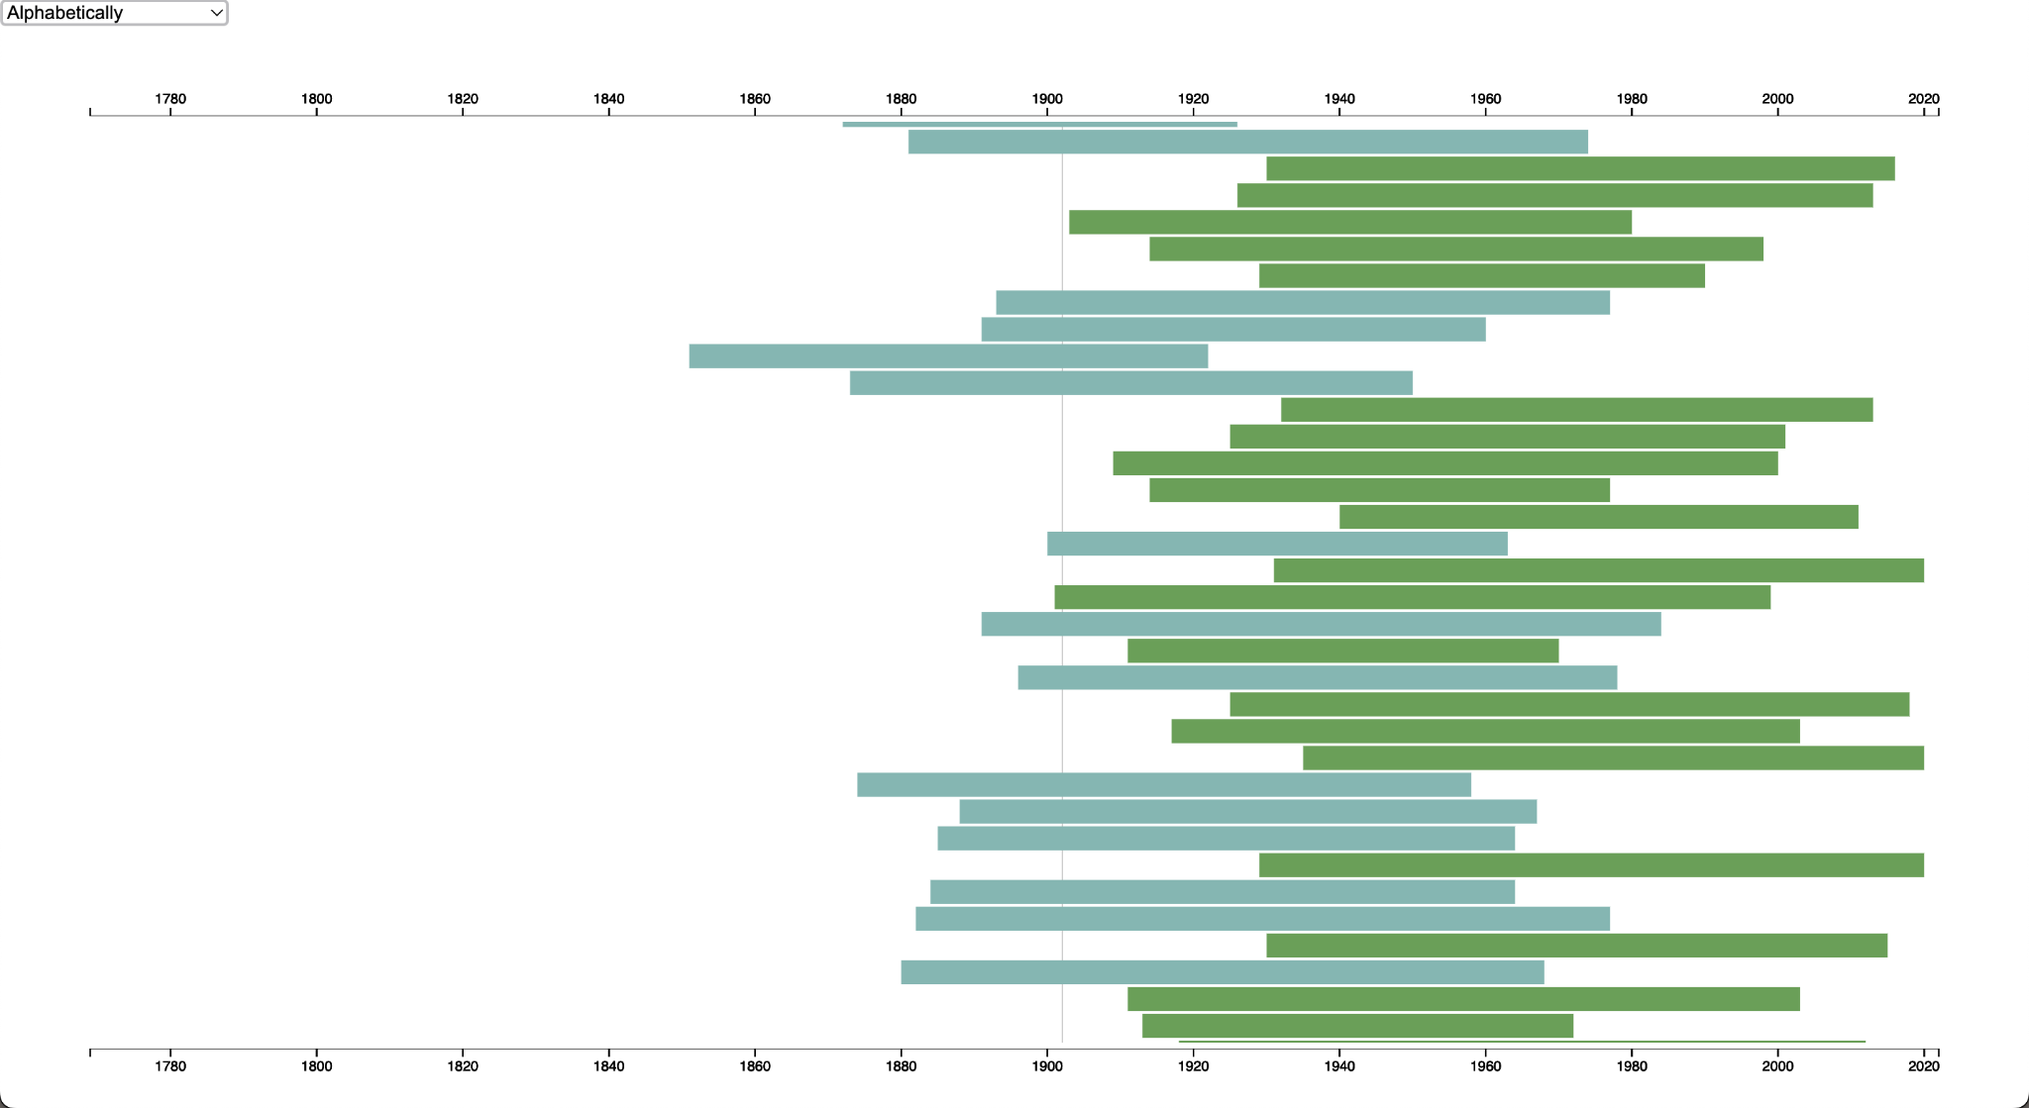

**Figure 16. D3.js Chronology Zoom Test Results - Zoom In**

**Table 18. D3.js Chronology Sort Unit Test**

| **D3.js Chronology - Sort** | | | | |
| --- | --- | --- | --- | --- |
| User Story | | 1.3 Chronology Data Visualization | | |
| Test Description | | Testing for sort functionality on D3.js chronology visualization. | | |
| Programs/Files | | GitHub, index.html, authors.csv | | |
| Step | Action | Expected Result | Actual Result | Status |
| 1 | Select “Alphabetically” from the dropdown. | Bars are sorted in alphabetical order. | Bars start with two out-of-place entries, and then continue in alphabetical order. | Fail |
| 2 | Select “Ascending Birth Year” from the dropdown. | Bars are sorted in ascending birth year order. | Bars are correctly sorted by ascending birth year. | Pass |
| 3 | Select “Descending Birth Year” from the dropdown. | Bars are sorted in ascending birth year order. | Bars are correctly sorted by descending birth year. | Pass |
| 4 | Select “Ascending Death Year” from the dropdown. | Bars are sorted in ascending death year order. | Bars are correctly sorted by ascending death year. | Pass |
| 5 | Select “Descending Death Year” from the dropdown. | Bars are sorted in descending death year order. | Bars are correctly sorted by descending death year. | Pass |
| 6 | Select “Ascending Lifespan” from the dropdown. | Bars are sorted in ascending lifespan order. | Bars begin with lifespans of 100+ and then continue in ascending order. | Fail |
| 7 | Select “Descending Lifespan” from the dropdown. | Bars are sorted in ascending lifespan order. | Bars begin descending from lifespans of 99 but end with lifespans of 100+. | Fail |

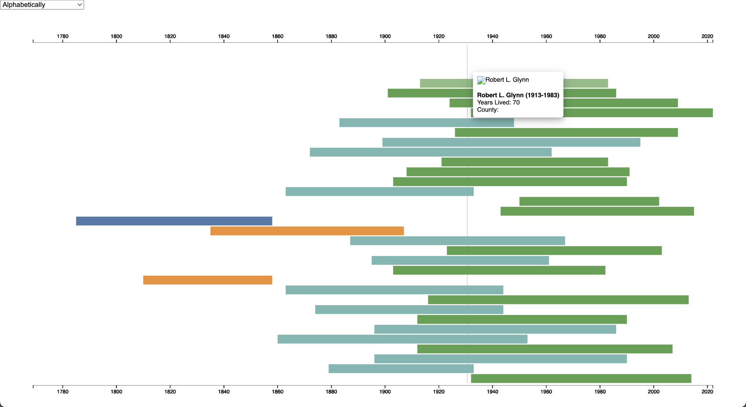

**Figure 17. D3.js Chronology Sort Test Results - Alphabetical**

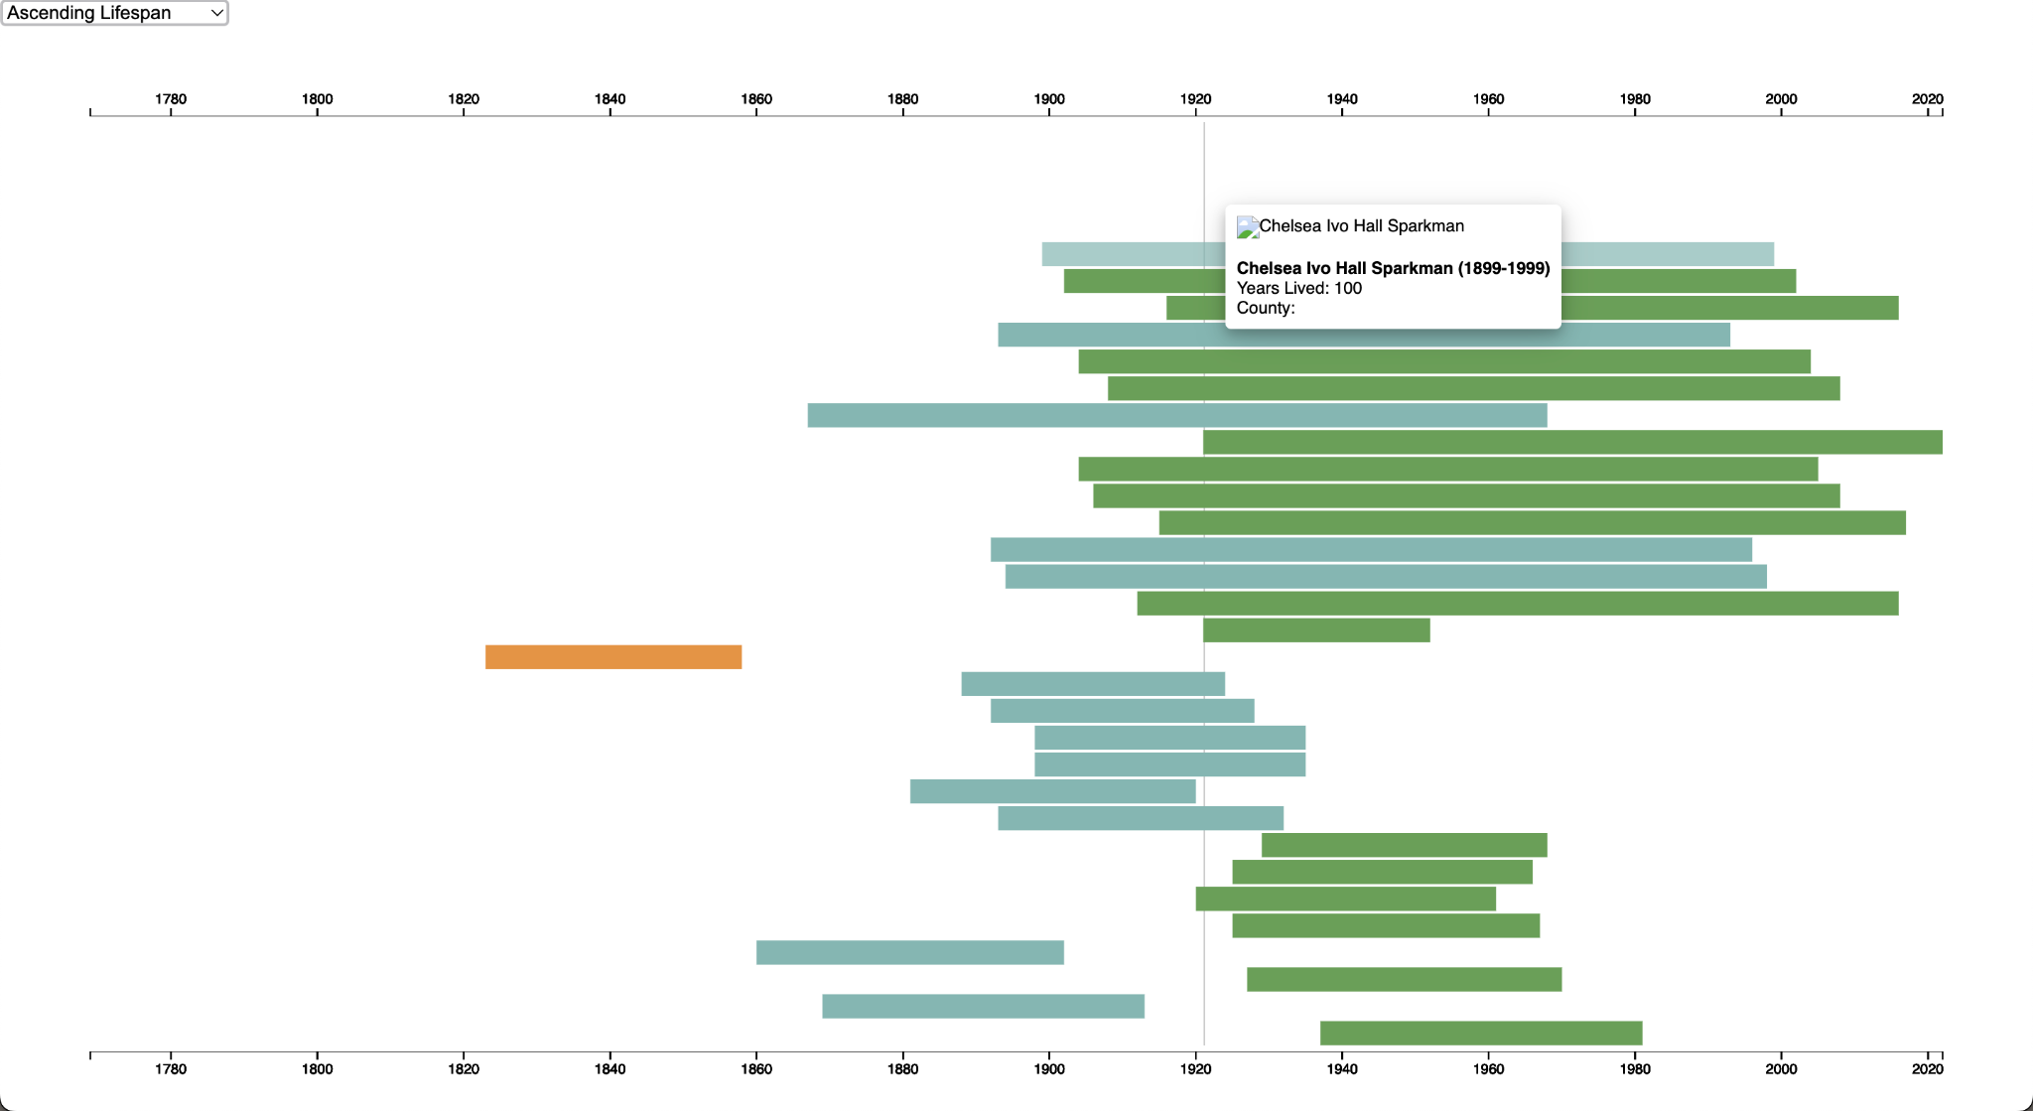

**Figure 18. D3.js Chronology Zoom Test Results - Ascending Lifespan**

## Test Logs

**Table 19. Test Log for D3.js Chronology Zoom Test**

| **D3.js Chronology - Zoom** | | | | |
| --- | --- | --- | --- | --- |
| User Story | | 1.0 Chronology Data Visualization | | |
| Tester | | Cady Pridgeon | | |
| Test Date | | 02/18/2024 | | |
| Test Result | | Pass | | |
| Comments | | All actions were successful! | | |

**Table 20. Test Log for D3.js Chronology Basic Functionality Test**

| **D3.js Chronology - Basic Functionality** | | | | |
| --- | --- | --- | --- | --- |
| User Story | | 1.0 Chronology Data Visualization | | |
| Tester | | Cady Pridgeon | | |
| Test Date | | 02/18/2024 | | |
| Test Result | | Pass | | |
| Comments | | All actions were successful! | | |

**Table 21. Test Log for D3.js Chronology Complex Functionality Test**

| **D3.js Chronology - Complex Functionality** | | | | |
| --- | --- | --- | --- | --- |
| User Story | | 1.0 Chronology Data Visualization | | |
| Tester | | Cady Pridgeon | | |
| Test Date | | 02/18/2024 | | |
| Test Result | | Pass | | |
| Comments | | All actions were successful! | | |

**Table 22. Test Log for D3.js Chronology Sort Test**

| **D3.js Chronology - Sort** | | | | |
| --- | --- | --- | --- | --- |
| User Story | | 1.3 Chronology Data Visualization | | |
| Tester | | Cady Pridgeon | | |
| Test Date | | 02/18/2024 | | |
| Test Result | | Fail | | |
| Comments | | The alphabetical, ascending lifespan, and descending lifespan sorts return incorrect visualizations. These are to be addressed in the next cycle. | | |

**Table 23. Neatline - Test Log for SIMILE Timeline Widget Test**

| **Neatline - Basic Functionality of SIMILE Timeline Widget** | | | | |
| --- | --- | --- | --- | --- |
| User Story | | 1.0, 1.2 Chronology Data Visualization | | |
| Tester | | Amee Kivette | | |
| Test Date | | 2/12/2024 | | |
| Test Result | | Pass | | |
| Comments | | Dublin Core information automatically links, but the specific collection may have to be changed. This information may need to be edited to include author descriptions and publications. | | |

**Table 24. Neatline - Test Log for Waypoints Widget Test**

| **Neatline - Basic Functionality of Waypoints Widget** | | | | |
| --- | --- | --- | --- | --- |
| User Story | | 1.0, 1.1, 1.2 Chronology Data Visualization | | |
| Tester | | Amee Kivette | | |
| Test Date | | 2/14/2024 | | |
| Test Result | | Pass | | |
| Comments | | Dublin Core information automatically links, but the specific collection may have to be changed. This information may need to be edited to include author descriptions and publications. | | |

# 

# Review Logs • Keanna Tennyson, Laura Wilson

**Table 25. Review Log for User Story 1.0**

| **Review Name** | | | | |
| --- | --- | --- | --- | --- |
| User Story | | 1.0 Chronology Data Visualization | | |
| Reviewer | | Cady Pridgeon, Laura Wilson, Keanna Tennyson, Amee Kivette | | |
| Review Date | | 02/08/2024 | | |
| Review Description | | Reviewed progress made with Omeka Classic timeline plugins | | |
| Review Result | | Pass | | |
| Comments | | A chronology was successfully created in Neatline and Neatline Time | | |

**Table 26. Review Log for User Story 1.1, 1.2**

| **Review Name** | | | | |
| --- | --- | --- | --- | --- |
| User Story | | 1.1, 1.2 Chronology Data Visualization | | |
| Reviewer | | Cady Pridgeon, Laura Wilson, Keanna Tennyson, Amee Kivette | | |
| Review Date | | 02/15/2024 | | |
| Review Description | | Reviewed author information in Neatline visualization | | |
| Review Result | | Pass | | |
| Comments | | Author name, description, photo, and link can be added within Neatline | | |

**Table 27. Review Log for User Story 1.3**

| **Review Name** | | | | |
| --- | --- | --- | --- | --- |
| User Story | | 1.3 Chronology Data Visualization | | |
| Reviewer | | Cady Pridgeon, Laura Wilson, Keanna Tennyson, Amee Kivette | | |
| Review Date | | 02/19/2024 | | |
| Review Description | | Reviewed sort functionality on D3.js visualization | | |
| Review Result | | Pass/Fail | | |
| Comments | | Sort works for the most part, but some edge cases are incorrect | | |

# Lessons & Challenges • Cady Pridgeon

## Lessons

The team learned that it is valuable to rapidly prototype to generate many potential solutions when working on a project with relatively flexible requirements. It can benefit research efforts when the solution must work and show promising results as opposed to completely committing to a tool without adequate prior knowledge.

Additionally, Dr. Rilett tasked the team with completing a usability questionnaire to provide user experience feedback for her project. This experience was eye-opening, as it guided the team to compare the Alabama Authors website to two other similar sites. This task helped the team understand where users are coming from when utilizing a resource like the Alabama Authors website. It is crucial to understand where users are coming from. This enforces ideas of accessibility requirements in the team’s minds.

## Challenges

Currently, the team’s primary technical challenges pertain to working around Omeka Classic. The most promising plugin, Neatline, requires manual data entries to visualize author information and enable each entry to become visible on the timeline widget. This plugin is also not fully customizable, which limits the potential functionality. Additionally, the custom-coded D3.js solution does not visualize in the Omeka Classic Exhibit Builder. Even when embedding the GitHub link in an iframe, the visualization does not appear. It has been a challenge to work around the restrictions set by Omeka Classic.

However, the team aims to resolve these issues by contacting the project web developer to talk through some of the more technical problems that have been faced. The team has also faced a slight standstill over the past couple of days since the team is awaiting sponsor feedback.

# Sponsor Approval • Cady Pridgeon

Our sponsor approves this report and endorses our work as presented.

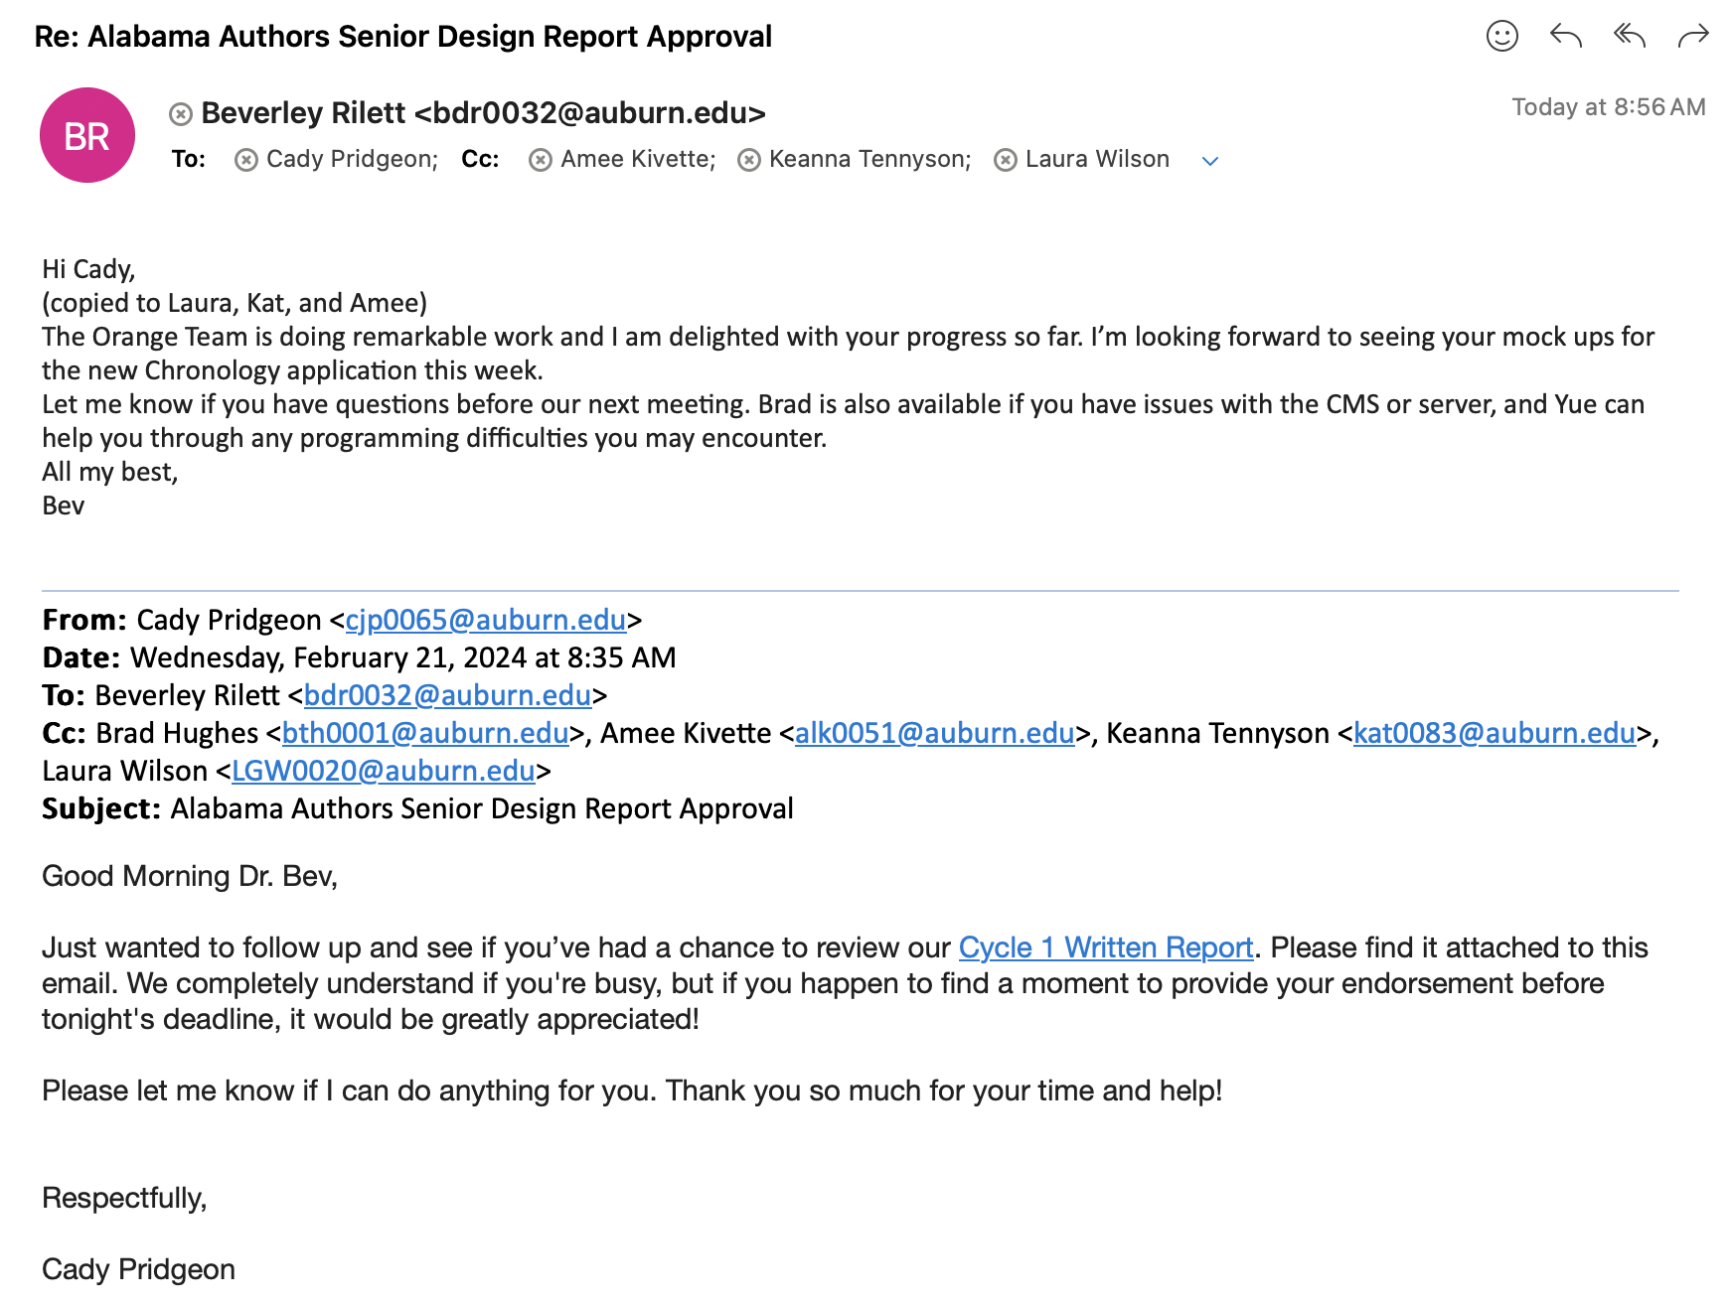

**Figure 19. Email correspondance containing sponsor approval from Dr. Beverley Rilett**

# 

# References • Cady Pridgeon

[1] Cady Pridgeon, Amee Kivette, Keanna Tennyson, and Laura Wilson. 2024. *Visualization: Architectural Spike*. COMP 4710 Senior Design Project 3 Team Orange Architectural Spike Written Report. Auburn University, Auburn, AL.

# 

# A. Appendix • Keanna Tennyson, Cady Pridgeon

## A.1. Meeting Minutes

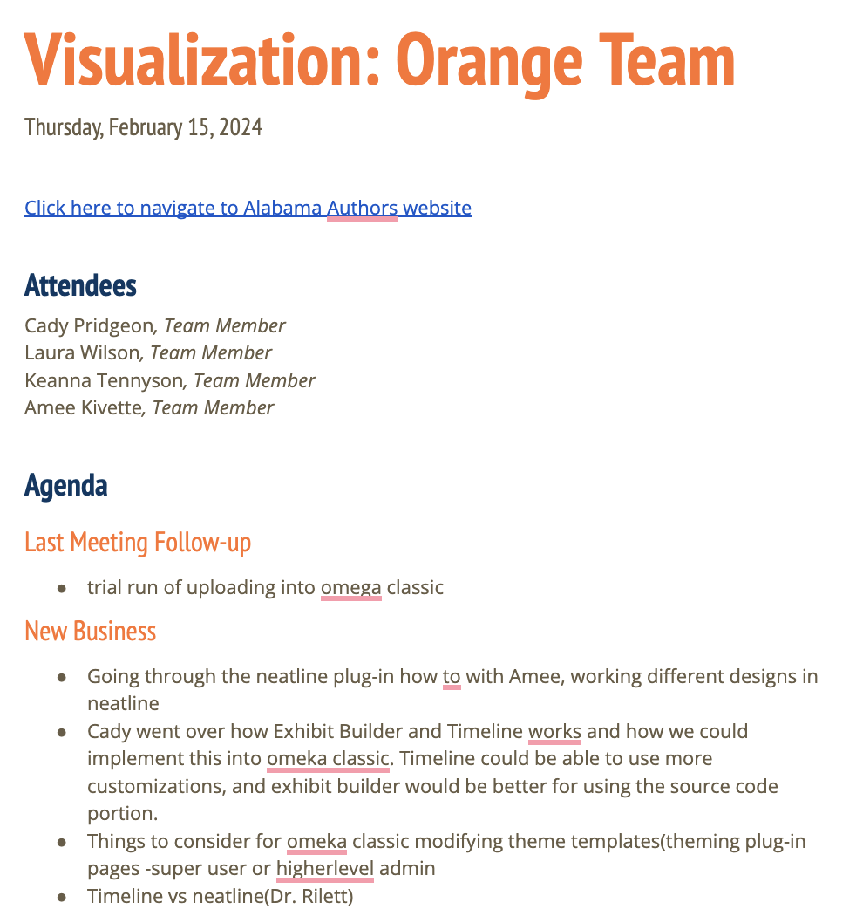

**Figure A1. February 15, 2024 Meeting Notes**

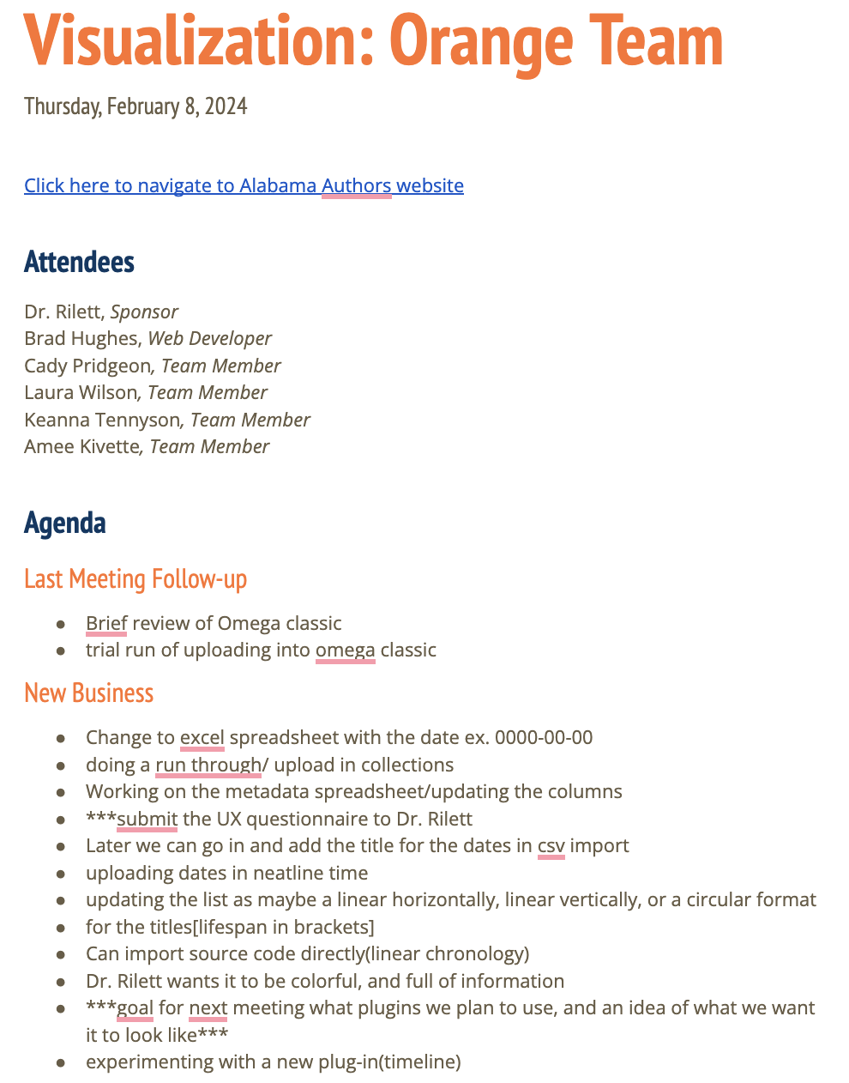

**Figure A2. February 8, 2024 Meeting Notes**

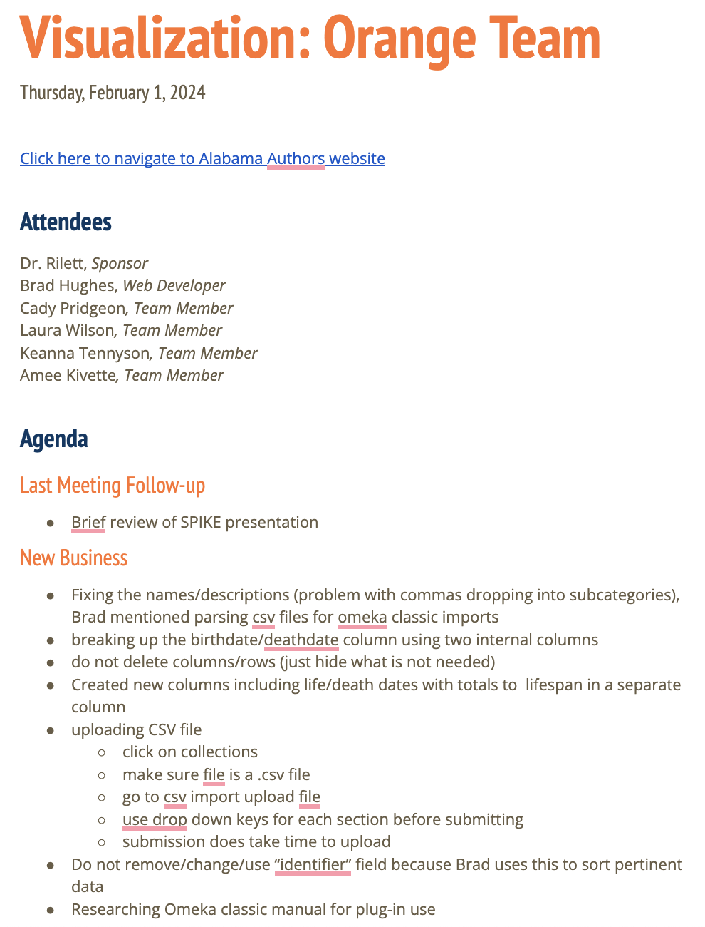

**Figure A3. February 1, 2024 Meeting Notes**



**Figure A4. January 25, 2024 Meeting Notes**

## 

## A.2. Correspondence

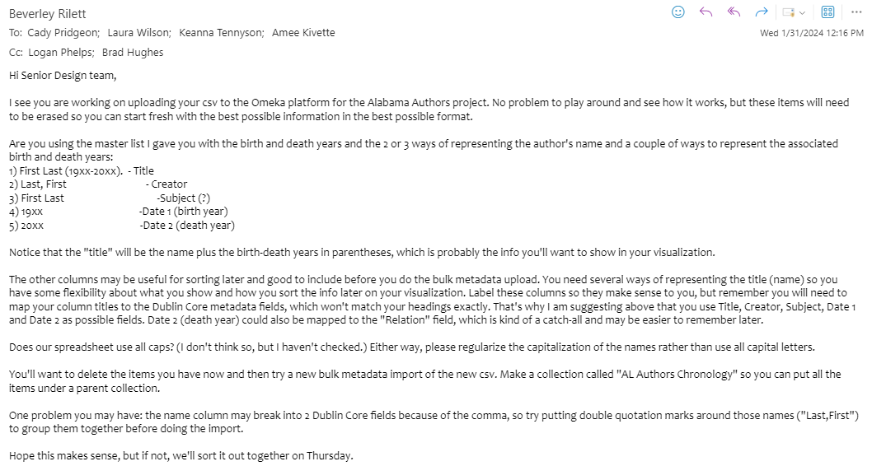**Figure A5. Email from Dr. Rilett to Team on January 31, 2024**

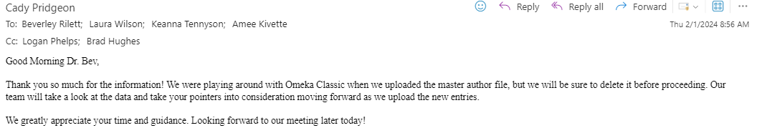

**Figure A6. Email from Cady Pridgeon to Dr. Rilett on February 1, 2024**

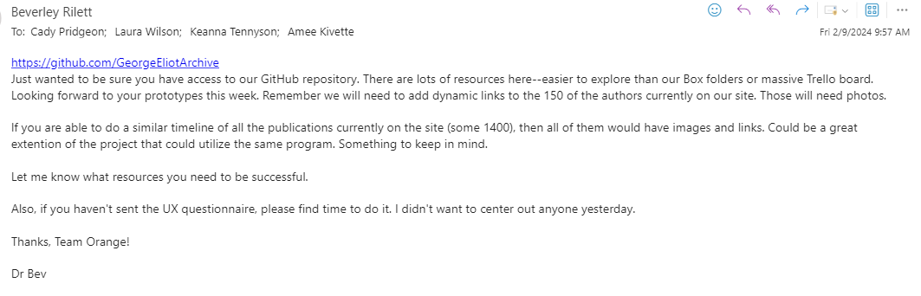

**Figure A7. Email from Dr. Rilett to Team on February 9, 2024**

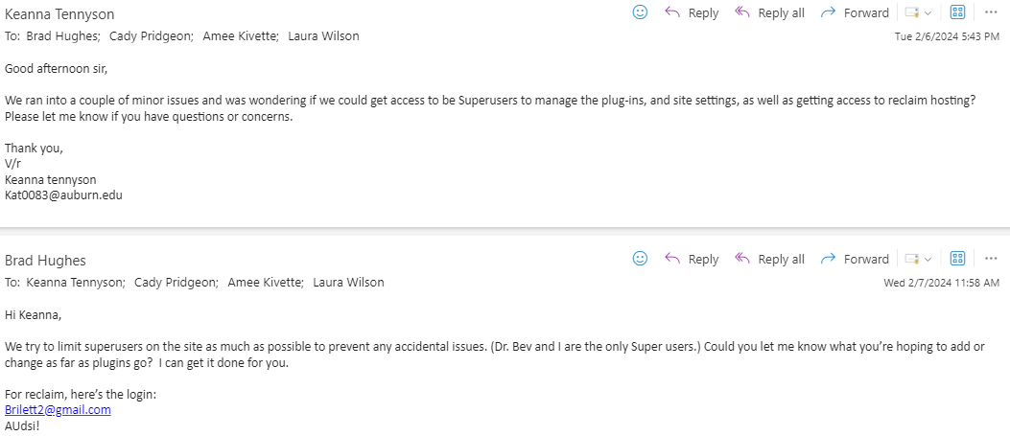

**Figure A8. Emails between Keanna Tennyson and Brad Hughes on February 6-7, 2024**

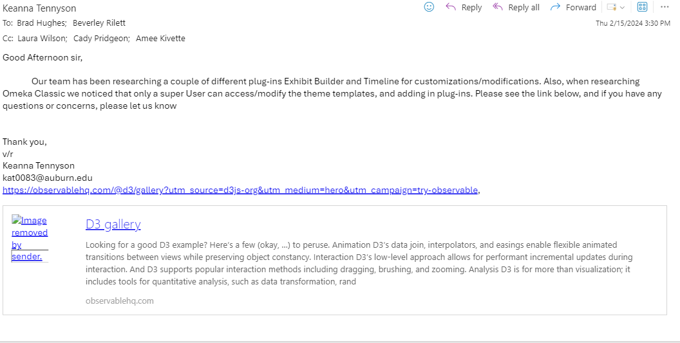**Figure A9. Email from Keanna Tennyson to Brad Hughes on February 15, 2024**

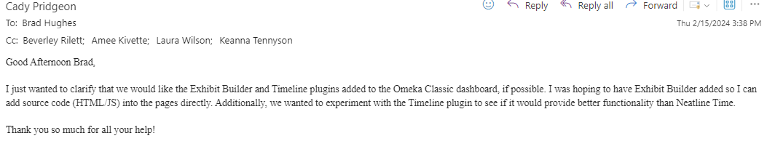

**Figure A10. Email from Cady Pridgeon to Brad Hughes on February 15, 2024**

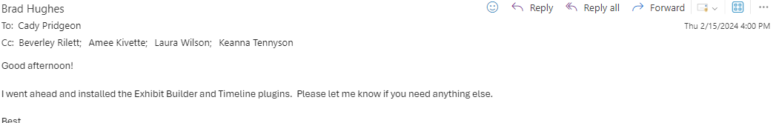**Figure A11. Email from Brad Hughes to Team on February 15, 2024**

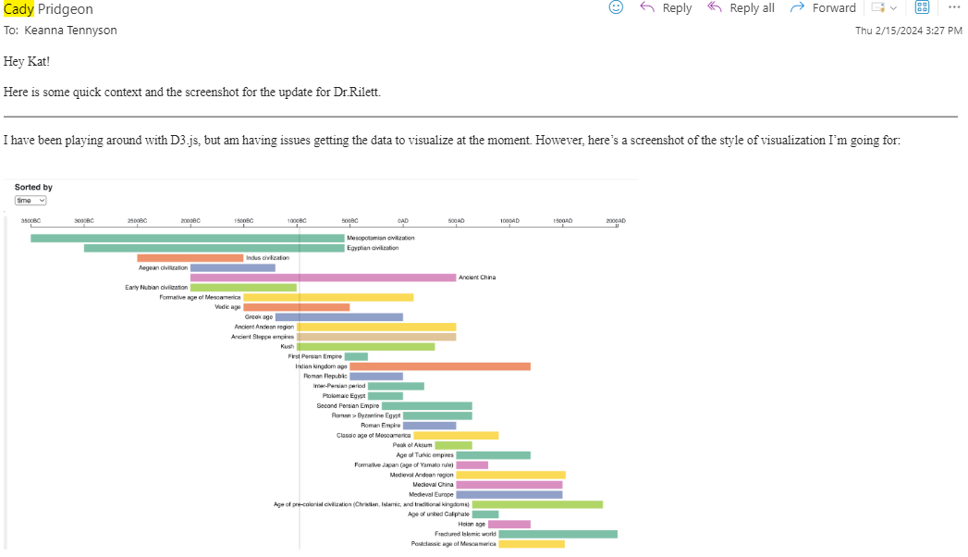

**Figure A12. Email from Cady Pridgeon to Keanna Tennyson on February 15, 2024**

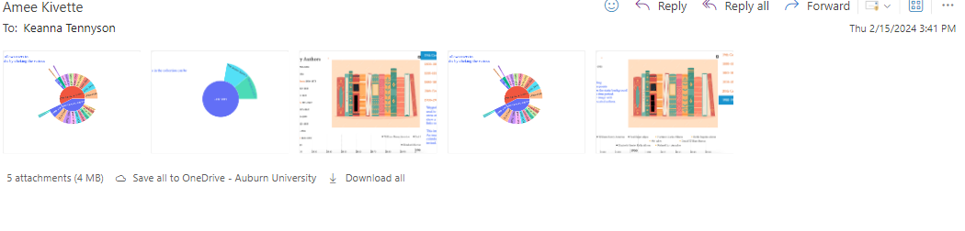

**Figure A13. Email from Amee Kivette to Keanna Tennyson on February 15, 2024**

## A.3. Project Resources

The Alabama Authors website is accessible at <https://alabamaauthors.org/>.

The D3.js data visualization website is accessible at <https://cadypridgeon.github.io/al-authors-chronology/>.

## A.4. Source Code

Please find the D3.js data visualization source code at <https://github.com/cadypridgeon/al-authors-chronology>.

## A.5. Version Description

**Omeka Classic - Version 1.0**

For the current solution on Omeka Classic, the Neatline, Neatline Time, and Timeline plugins offer three various timeline visualizations of the complete Alabama Authors data.

Key Features:

* Neatline functionality for viewing authors by period
* Neatline functionality for viewing author name, lifespan, photo, and details page from the visualization
* Neatline Time and Timeline secondary functionality available

Bugs & Issues:

* Neatline Time and Timeline produce slow and limited visualizations
* Neatline uses a placeholder image for now
* Neatline requires manual data entry

**D3.js - Version 1.0**

For the current solution using D3.js, the visualization processes the complete Alabama Authors data in an interactive format.

Key Features:

* Zoomable chart to highlight the magnitude of data
* Hover states available for additional author information
* Produces an interesting and modern visualization that is sortable

Bugs & Issues:

* Does not interface with the Omeka Classic system
* Some sort functionality is not bug-free
* Photos and detail links require manual data entry

## A.6. Current Cycle Documents

Please find the Cycle 1 presentation slides at

<https://docs.google.com/presentation/d/1dCdi89m2akV9EBTnaWofOgszXSbSbXZUkI8wMOTK7DE/edit?usp=sharing>.

Please find the Cycle 1 video demonstrations at

<https://drive.google.com/drive/folders/1Z0F39J37Z6FhKg9cdXBwnPmedI69c-tY?usp=sharing>.

Please find the Cycle 1 status reports at <https://drive.google.com/drive/folders/1YI2GOD4i00iMbaioBki-ftXrqV9SysNa?usp=sharing>.

## A.7. Previous Cycle Documents

**Architecture Spike**

* Written Report: <https://docs.google.com/document/d/1tvpr4m6h3w0GzWS8NE92hoHThVsdL3VSgvgN68JwWhA/edit?usp=sharing>
* Presentation Slides: <https://docs.google.com/presentation/d/1CTxNb0ZgCglFvZK_e8i7icP9M2q5okNBbJfL5kEeI-k/edit?usp=sharing>